Year 9 |  | Right Triangle Trigonometry | Calculator  Allowed
Skills and Knowledge Assessed:  - Use similarity to investigate the constancy of the sine, cosine and tangent ratios for a given angle in right - angled triangles (ACMMG223)  - Apply trigonometry to solve right - angled triangle problems (ACMMG224)  - Solve right- angled triangle problems including those involving direction and angles of elevation and depression (ACMMG245) |  |  | Name_________________
Section 1 Short Answer Section
Write all working and answers in the spaces provided on this test paper.

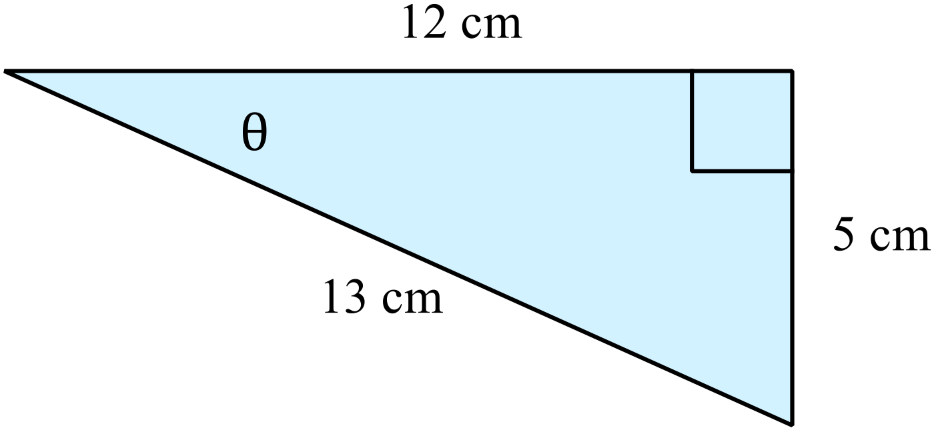In the diagram, what is the value of 

……………………………………………....
………………………………………………
 | ……………………………………………………………………………………………….
 | ……………………………………………………………………………………………….
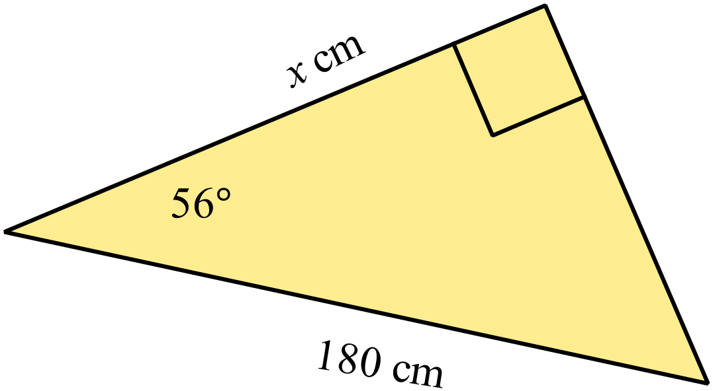Find the value of x, correct to the nearest cm.

………………………………………………
……………………………………………....
………………………………………………
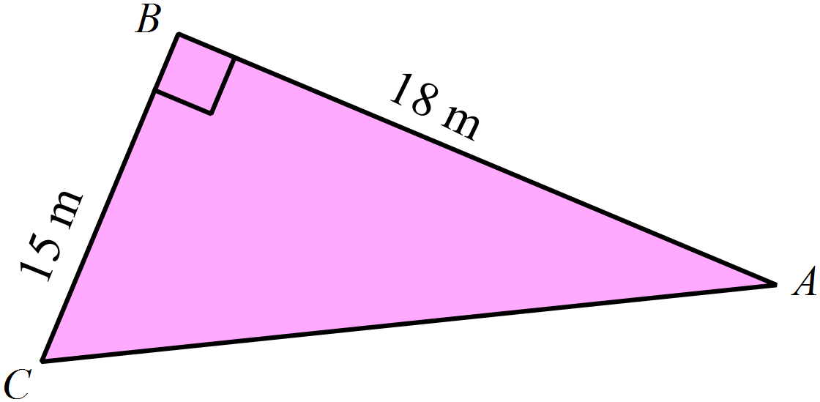Find the size of  , to the nearest degree.
………………………………………………
……………………………………………....
………………………………………………
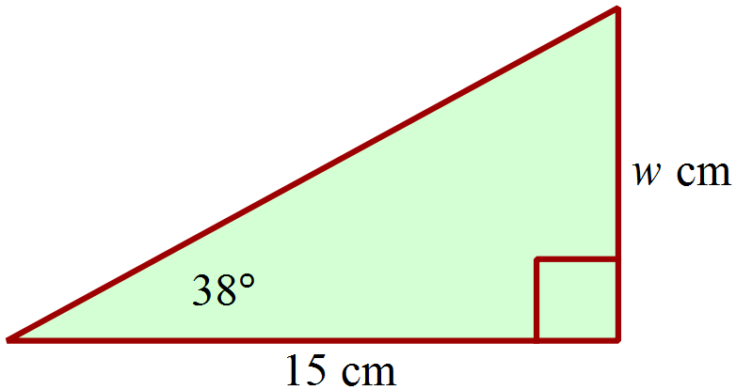Find the value of w, correct to 1 decimal place.

……………………………………………....
………………………………………………
……………………………………………….
Find the value of, to the nearest degree.
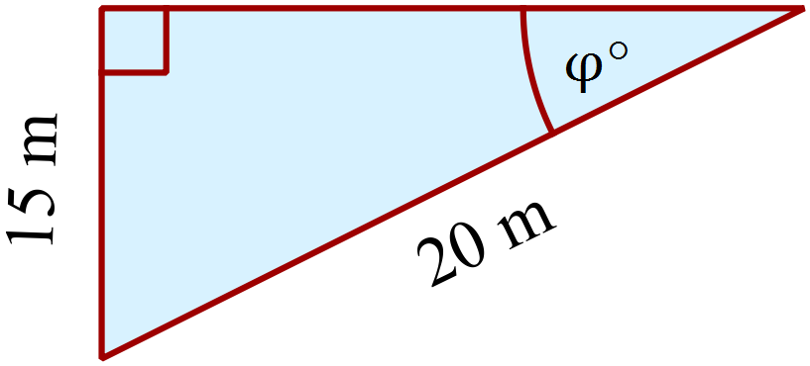
……………………………………………....
………………………………………………
……………………………………………….
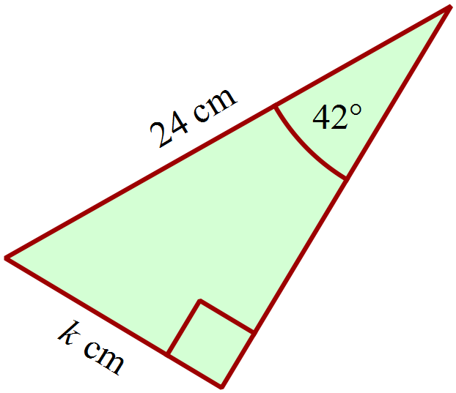Find the value of k, correct to 1 decimal place.

..…………………………………………....
………………………………………………
……………………………………………….
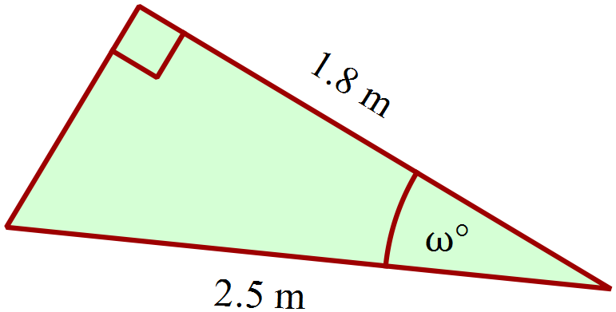 Find the value of, correct to the nearest degree.
………………………………………………
……………………………………………....
………………………………………………
……………………………………………….
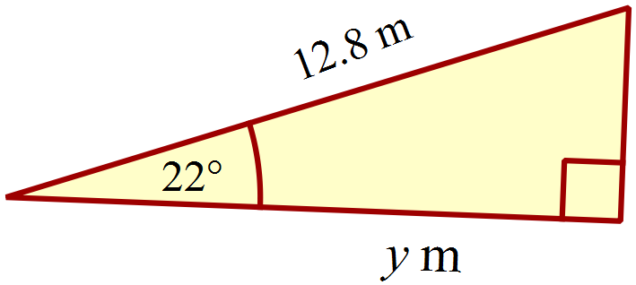What is the value of y, correct to 3 significant figures?

……………………………………………....
………………………………………………
……………………………………………….
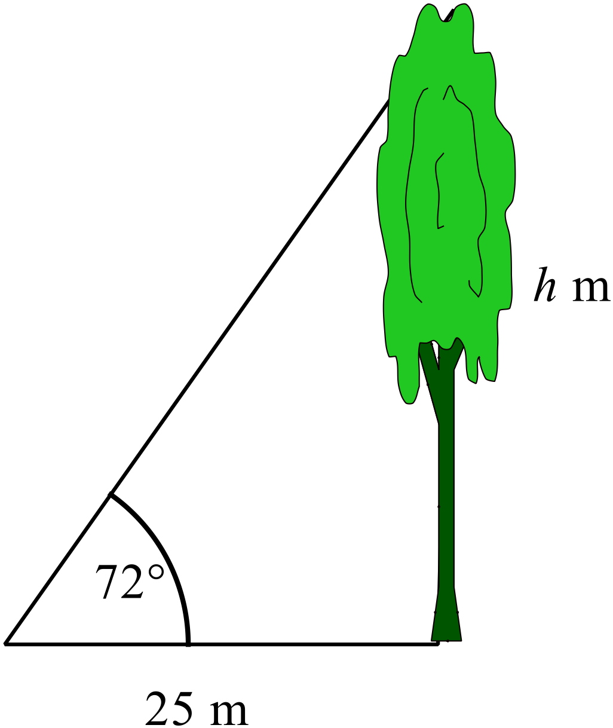Find the height of the tree (h), correct to the nearest 10th of a metre.

………………………………………………
……………………………………………....
………………………………………………
………………………………………………
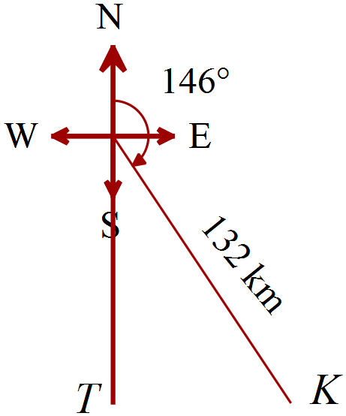Kevin and Tim both leave Manjimup by plane at midday.
Kevin flies 132 km on a bearing 146º before landing.
Tim flies due south, and lands at a point which is due west of where Kevin lands.
How far apart are Tim and Kevin when they land?
………………………………………………
……………………………………………....
………………………………………………
……………………………………………….
Town B is 20 km south of town C.
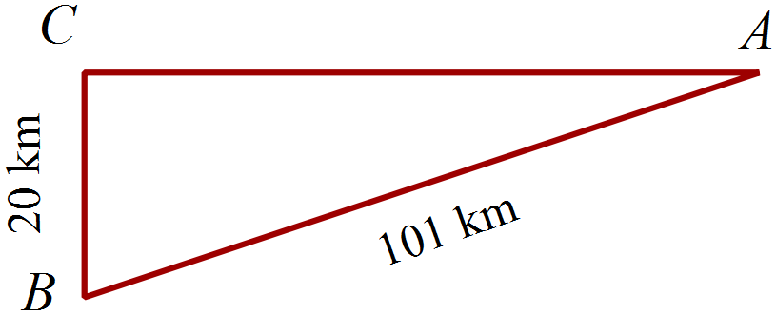Town A is due east of town C.
The distance from town A to town B is 101 km.
What is the bearing of town B from town A?
……………………………………………....
………………………………………………
……………………………………………….
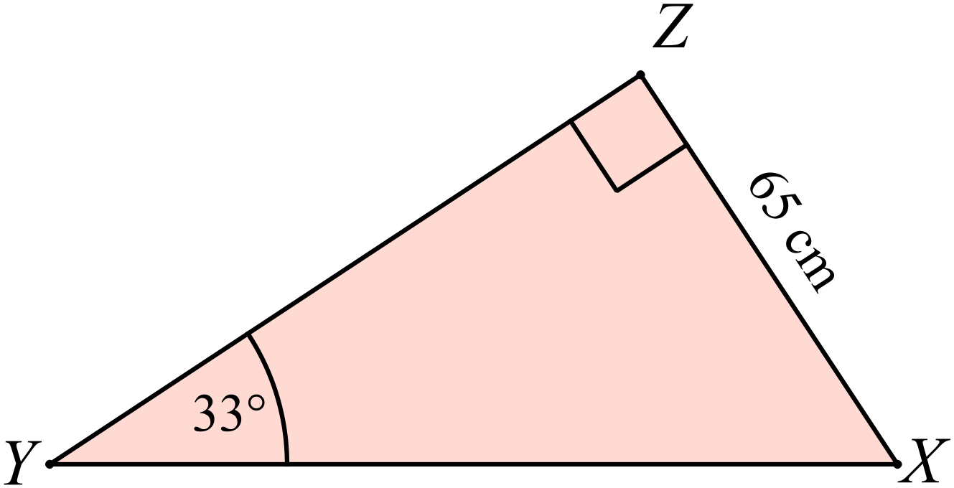Find the length of 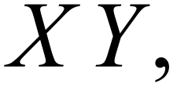 correct to 1 decimal place.

……………………………………………....
………………………………………………
……………………………………………….
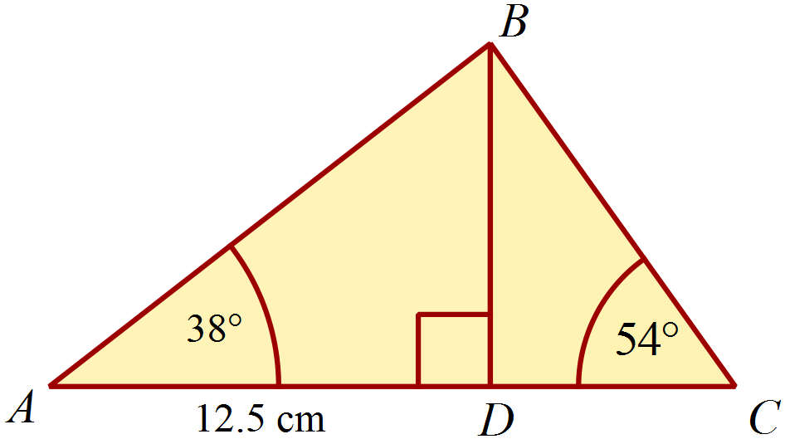The distance AD = 12.5 cm and 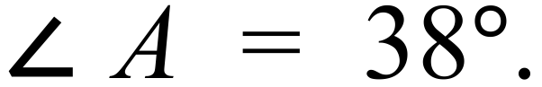
Find the distance DC.
.…………………………………………………
.…………………………………………………
………………………………………………….
…….……………………………………………

Year 9 |  | Right Triangle Trigonometry | Calculator Allowed
 |  | Right Triangle Trigonometry | Name_________________
Section 2 Multiple Choice Section
Mark all your answers on the accompanying multiple choice answer sheet, not on this test paper. You may do any working out on this test paper. Calculators are allowed for this section.

 | A. 2.87 B. 7.47 C. 8.57 D. 20.84
In which triangle is 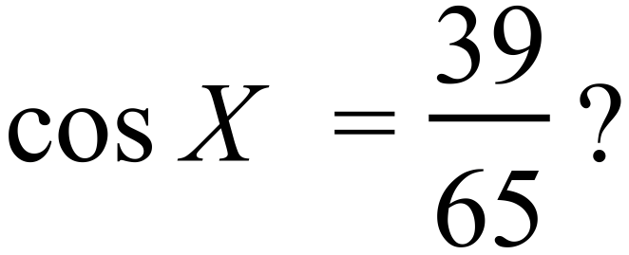

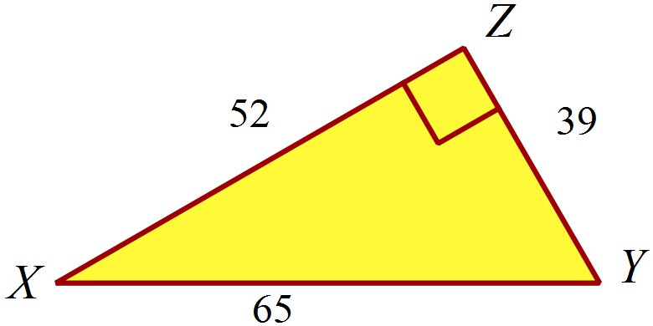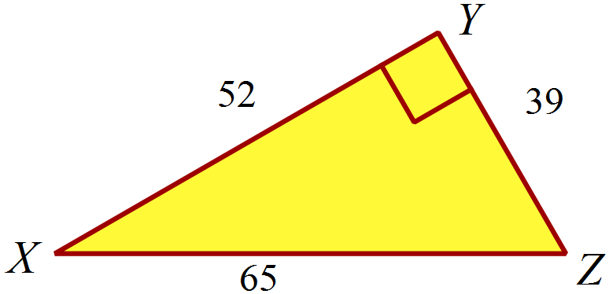 A. B.

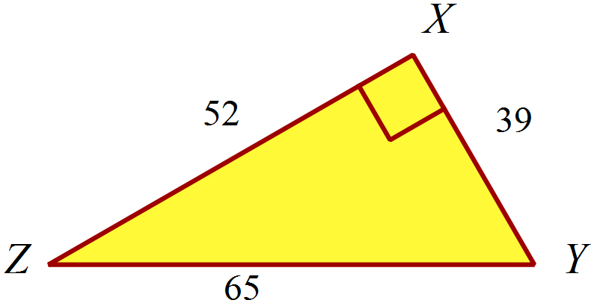 C. D.
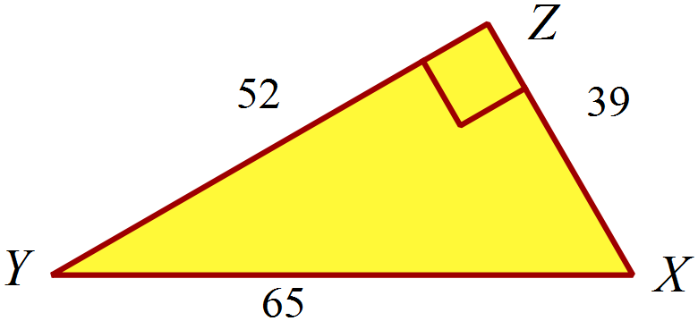


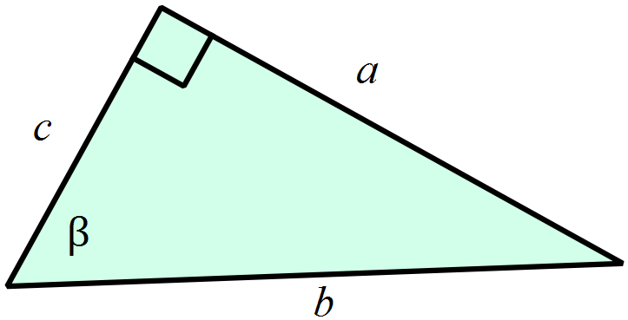 A.  B. 

C.  D. 

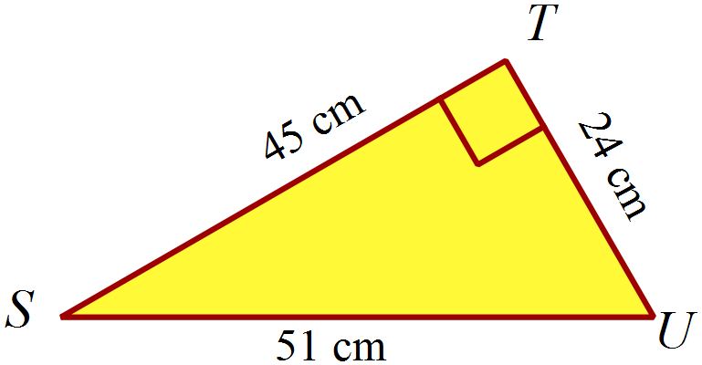Find the size of 
A. 29 º
B. 32 º
C. 57 º
D. 62º
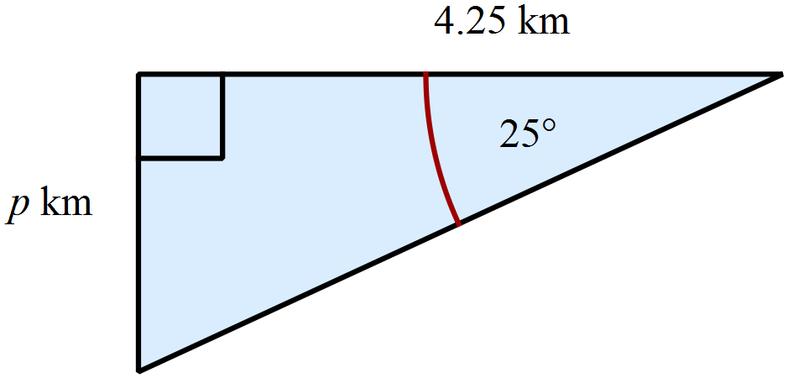Find the value of p correct to two decimal places.

A. 1.80 km
B. 1.98 km
C. 3.85 km
D. 10.06 km
Find the value of d correct to one decimal place.
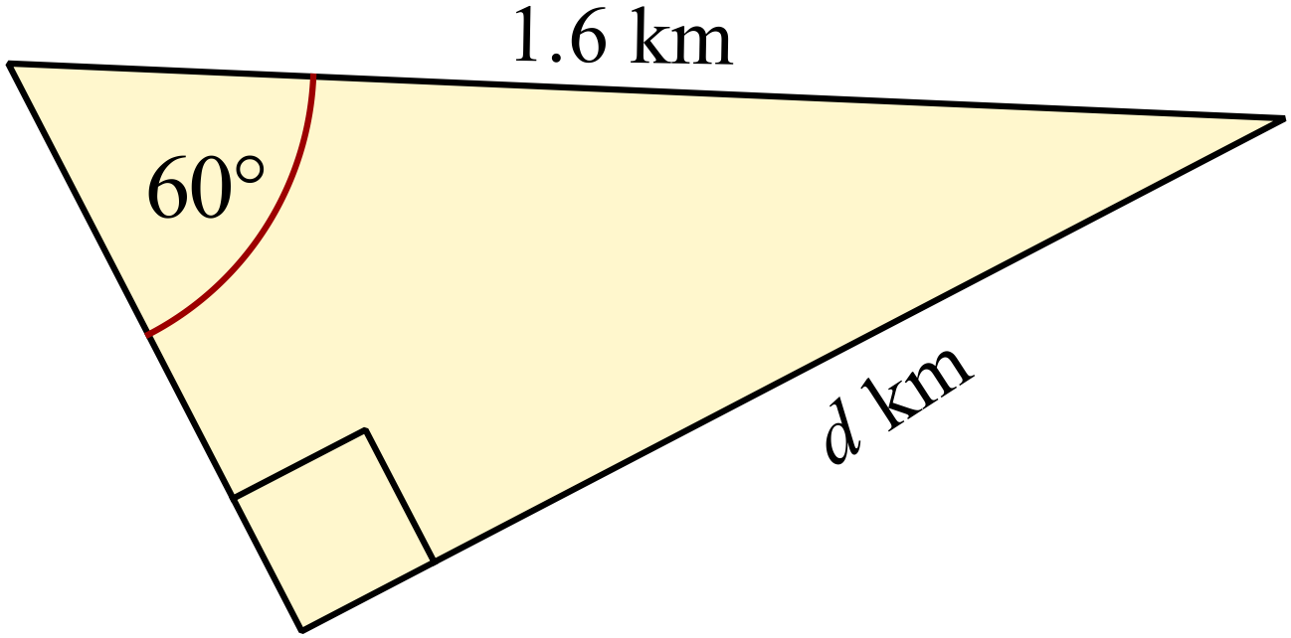
A. 0.8 km
B. 1.4 km
C. 1.8 km
D. 2.8 km
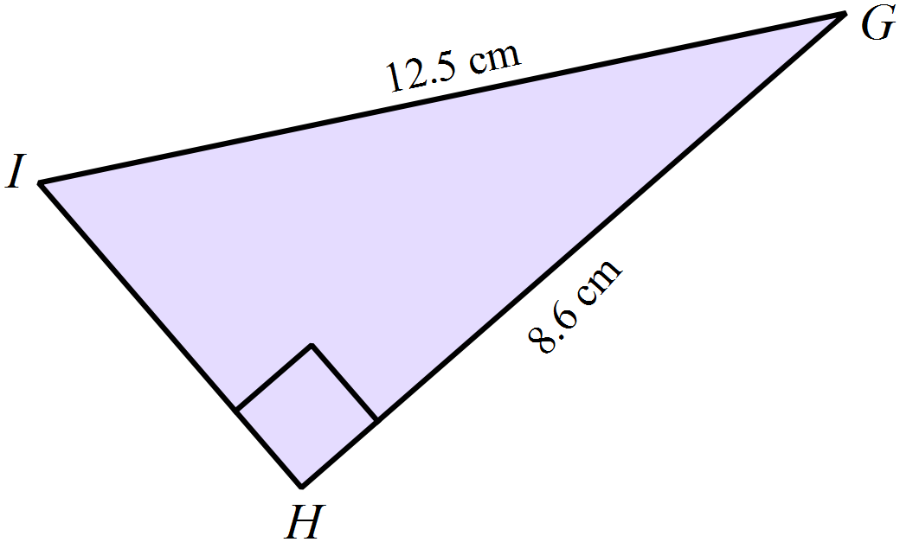Find the size of  correct to the nearest degree.

A. 35º
B. 36 º
C. 47 º
D. 54 º
Find the length of BC correct to one decimal place.
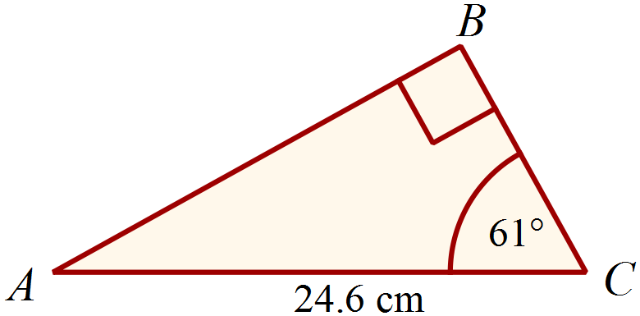
A. 11.9 cm
B. 21.5 cm
C. 28.1 cm
D. 44.4 cm
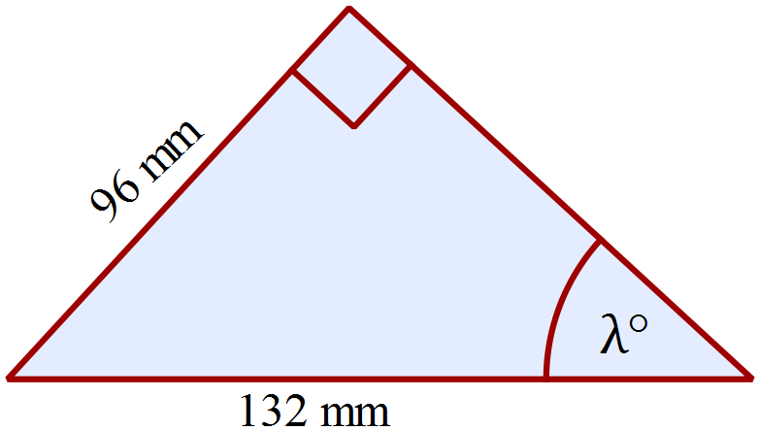What is the value of 

A. 36 º
B. 38 º
C. 43 º
D. 47º
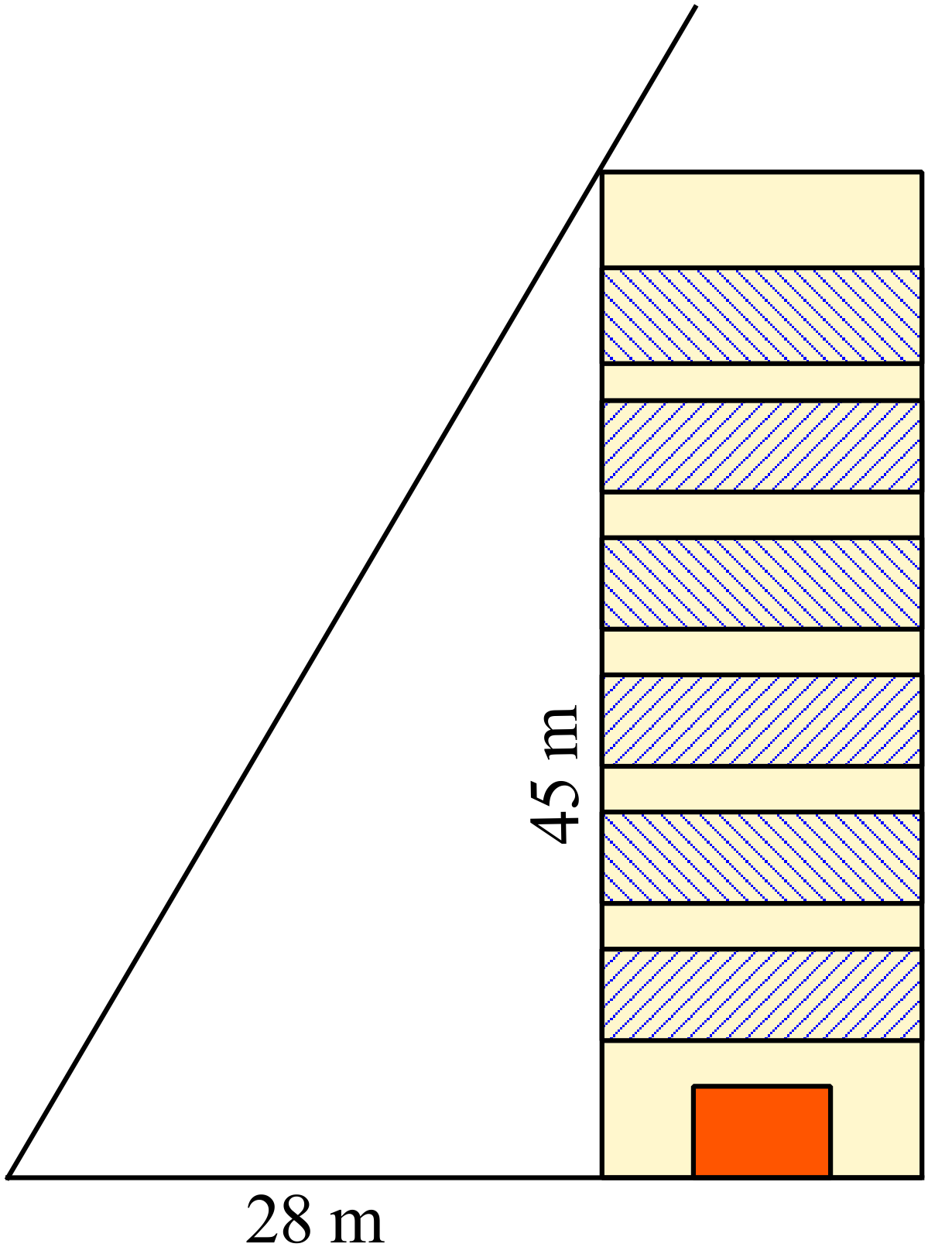At a certain time of day, a building which is 45 m tall, casts a shadow which is 28 m long.
What is the angle of elevation of the sun at this time?

A. 31º
B. 38 º
C. 51 º
D. 58 º
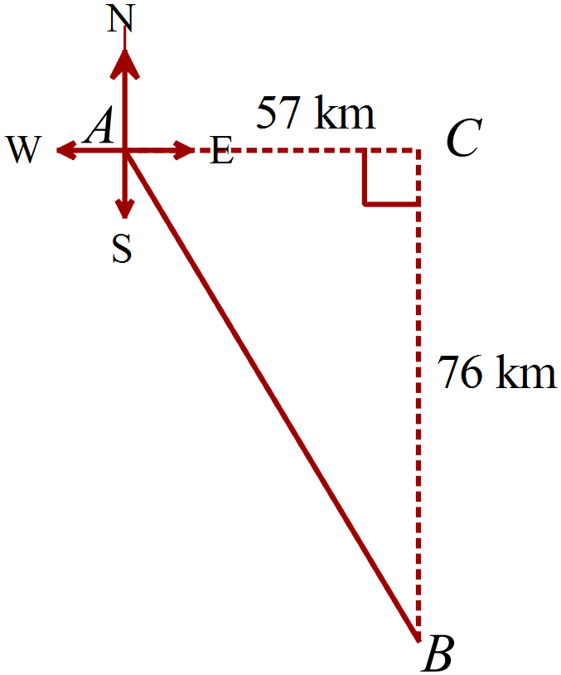AC = 57 km and BC = 76 km.
What is the bearing of B from A?

A. 034º
B. 139 º
C. 143 º
D. 233 º
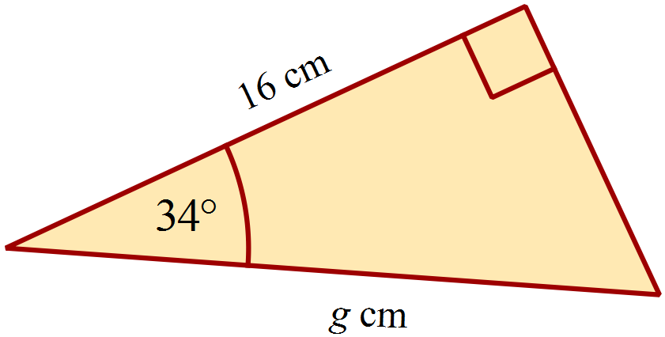What is the value of g?

A. g = 10.8
B. g = 19.3
C. g = 23.7
D. g = 28.6
Two towns E and G lie in a straight line which runs up the slope of a hill.
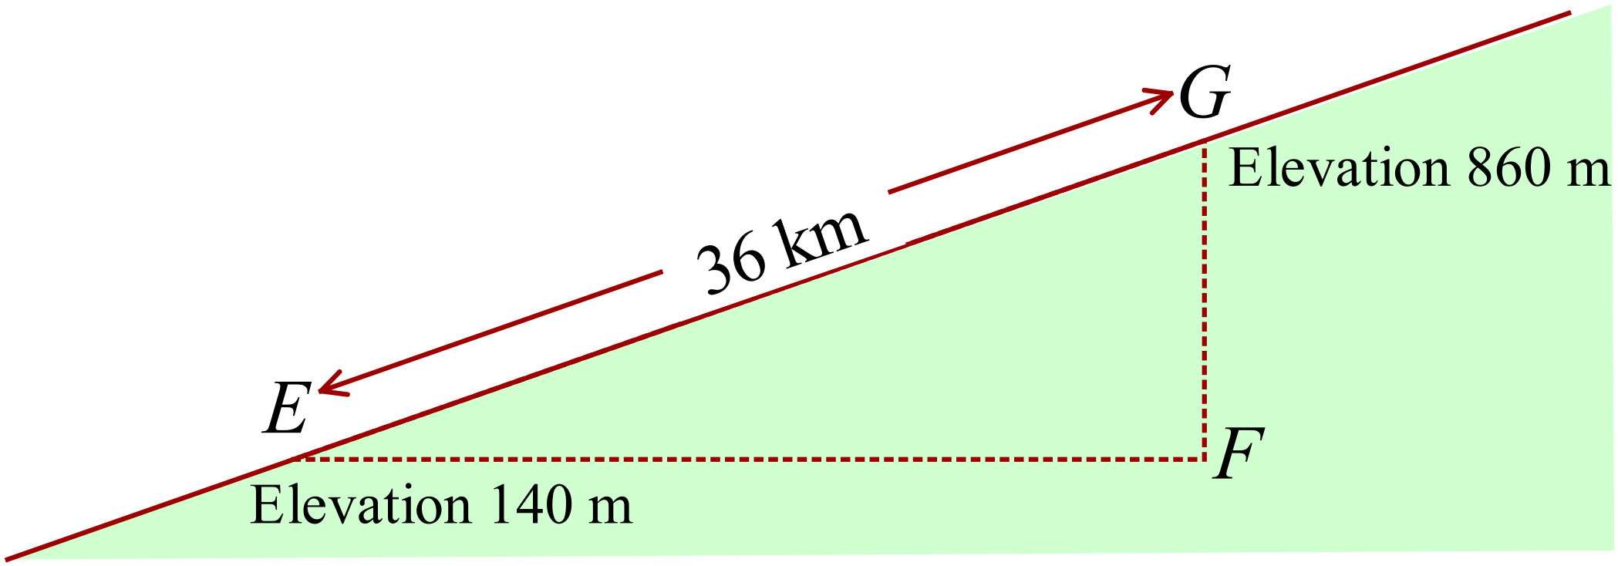The towns E and G are 36 km apart.
Town E has an elevation of 140 m above sea level and G has an elevation of 860 m.
What is the slope of the hill?
A. 1º B. 11 º
C. 52 º D. 88 º
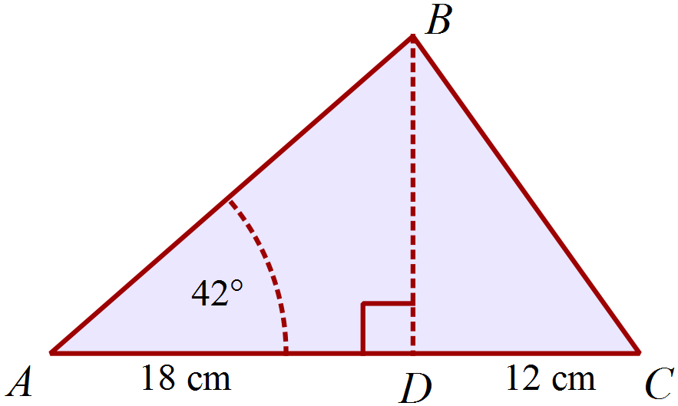In , 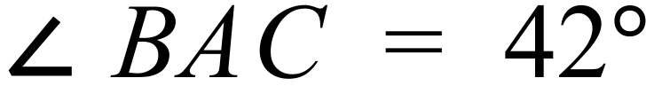 .
D is a point on AC such that AD = 18 cm and DC = 12 cm.
What is the area of .
A. 243.1 cm³
B. 299.9 cm³
C. 363.3 cm³
D. 403.5 cm³
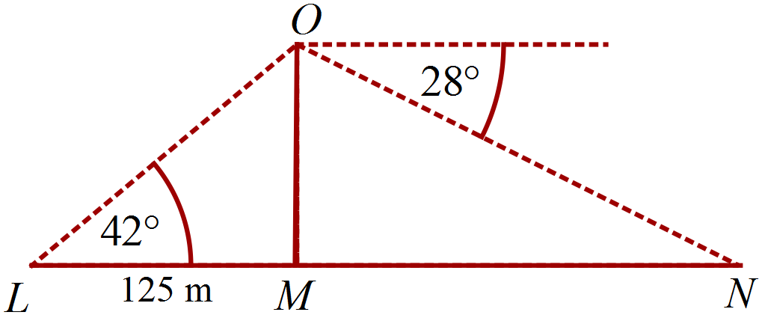Points L, M and N lie in a straight line on level ground.
L is 125 m from the base of a vertical tower OM.
The angle of elevation of O from L is 42º.
The angle of depression of N from O is 28º.
How far is L from N ?

A. 185 m
B. 214 m
C. 337 m
D. 399 m

Multiple Choice Answer Sheet
Right Triangle Trigonometry
Name _____________________________________________
Completely fill the response oval representing the most correct answer.

1. A B C D
2. A B C D
3. A B C D
4. A B C D
5. A B C D
6. A B C D
7. A B C D
8. A B C D
9. A B C D
10. A B C D
11. A B C D
12. A B C D
13. A B C D
14. A B C D
15. A B C D
Year 9 |  | Right Triangle Trigonometry | Calculator
Section 1 Short Answer Section
ANSWERS
No. | WORKING |  | ANSWER
 | 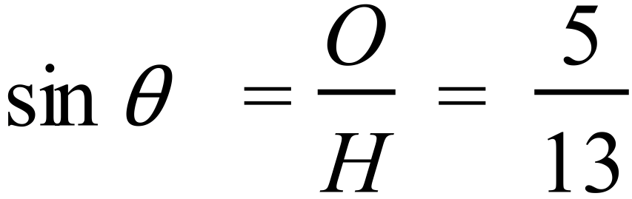 |  | 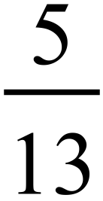
 | 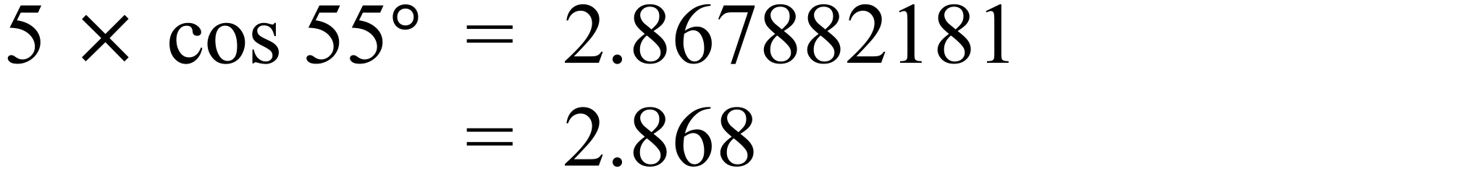 |  | 2.868
 | 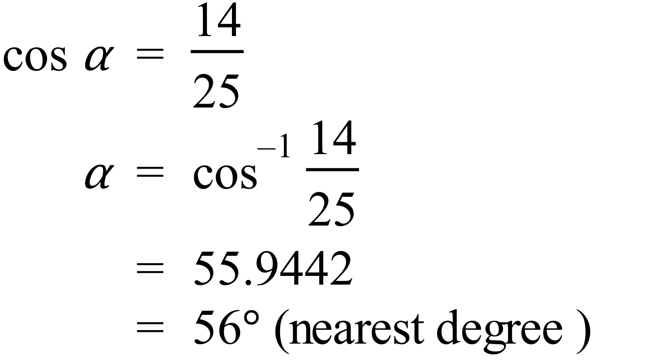 |  | 56º
 | 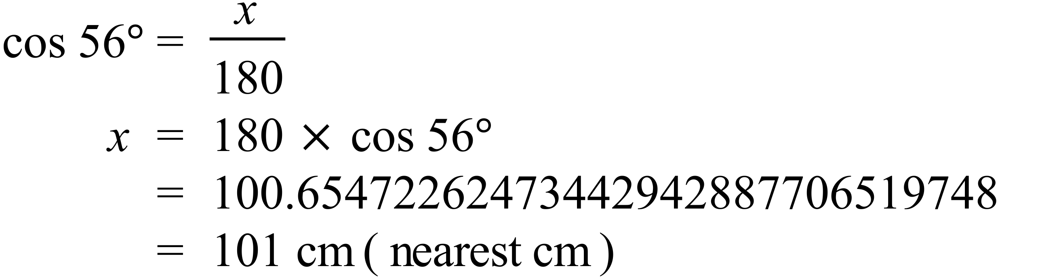 |  | 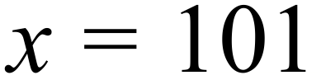
 | 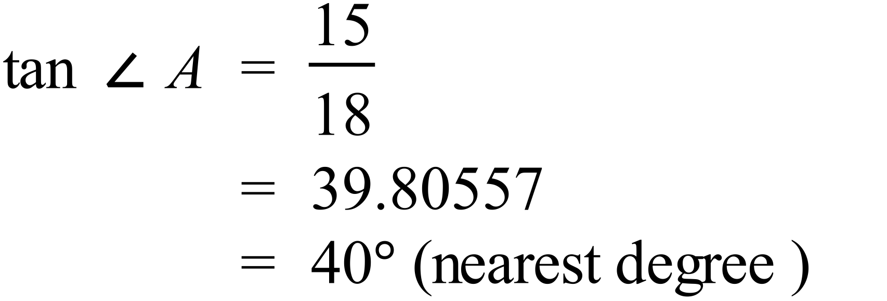 |  | 40º
 | 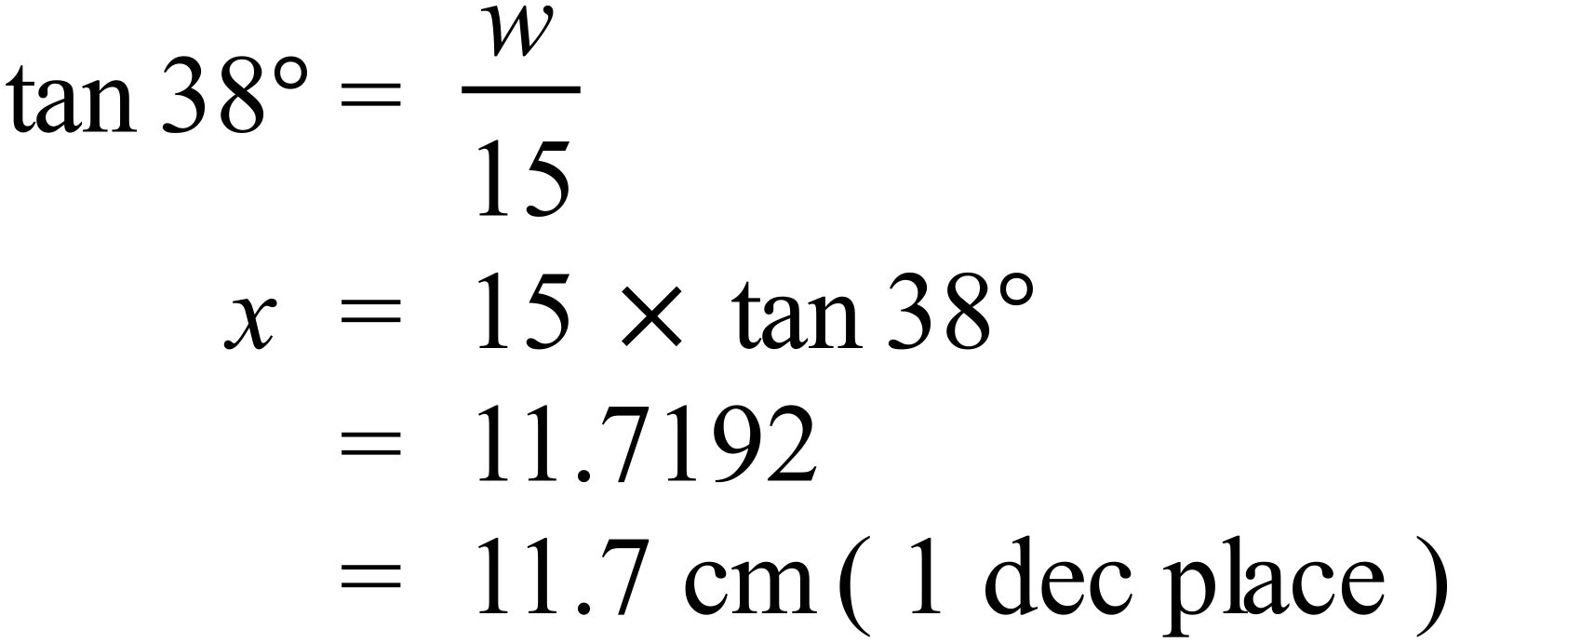 |  | 11.7 cm
 | 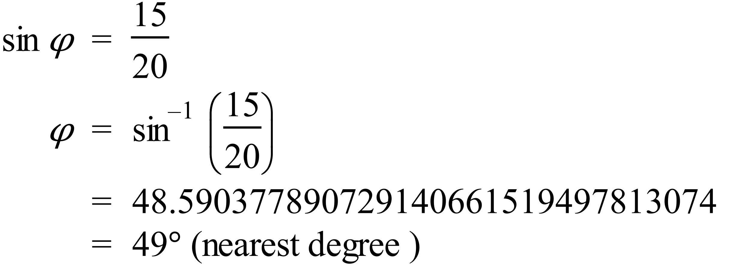 |  | 49º
 | 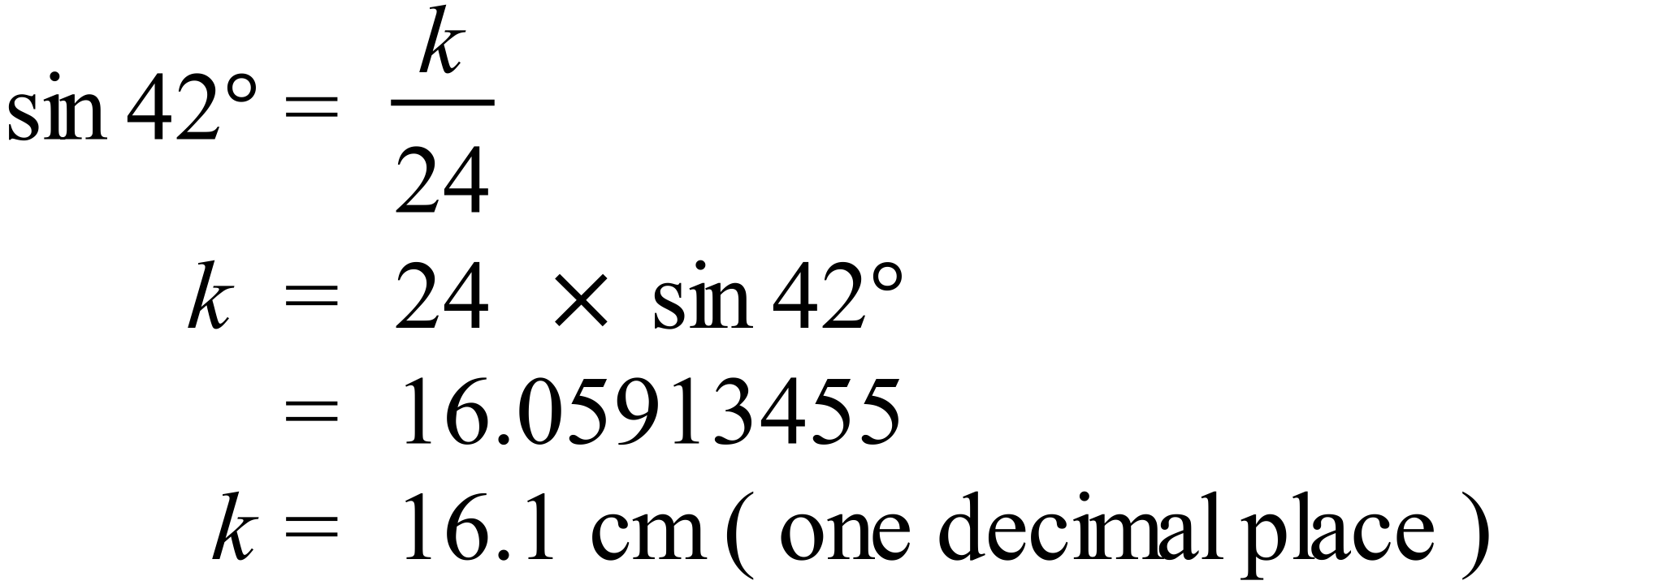 |  | 16.1
 | 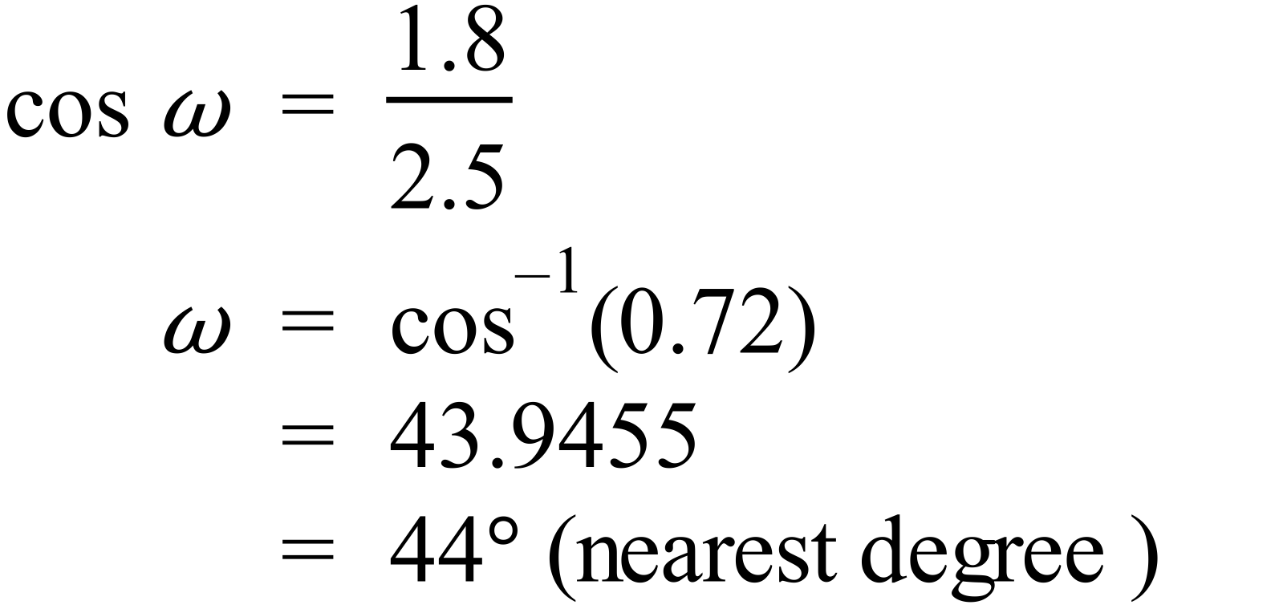 |  | 44º
 | 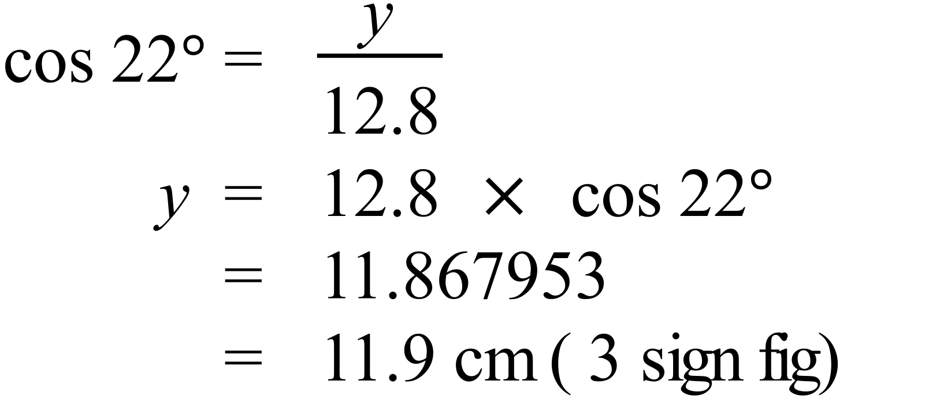 |  | 11.9 cm
 | 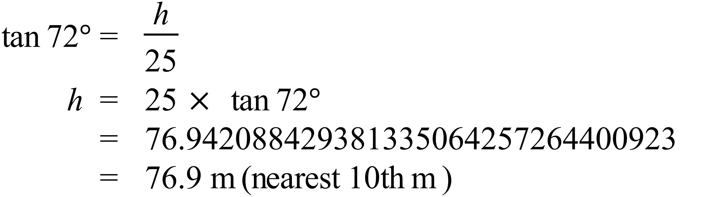 |  | 76.9 m
 | 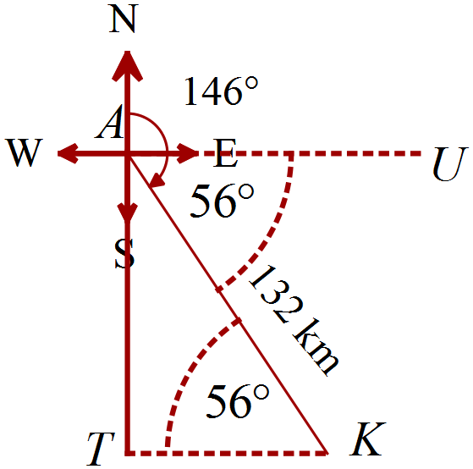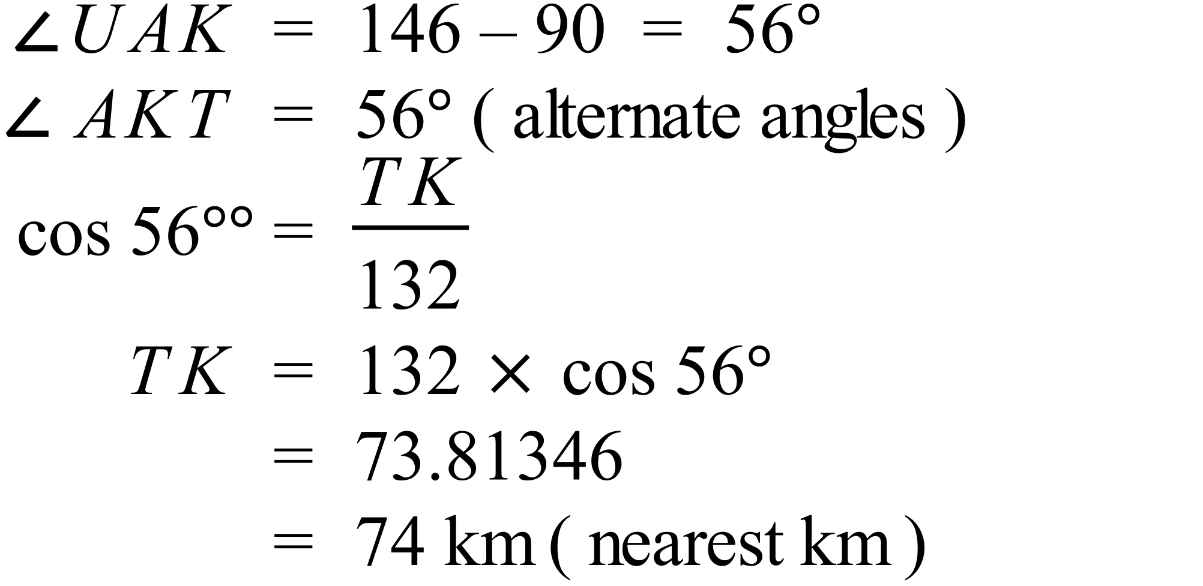 |  | 74 km
 | 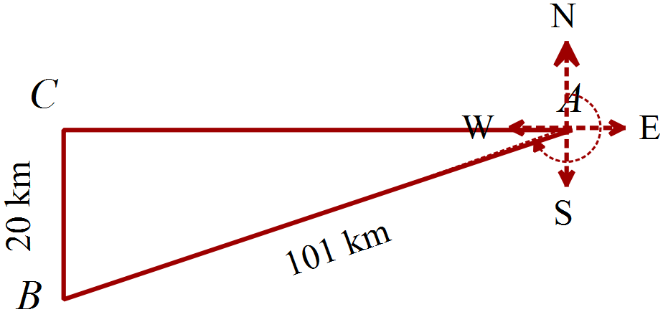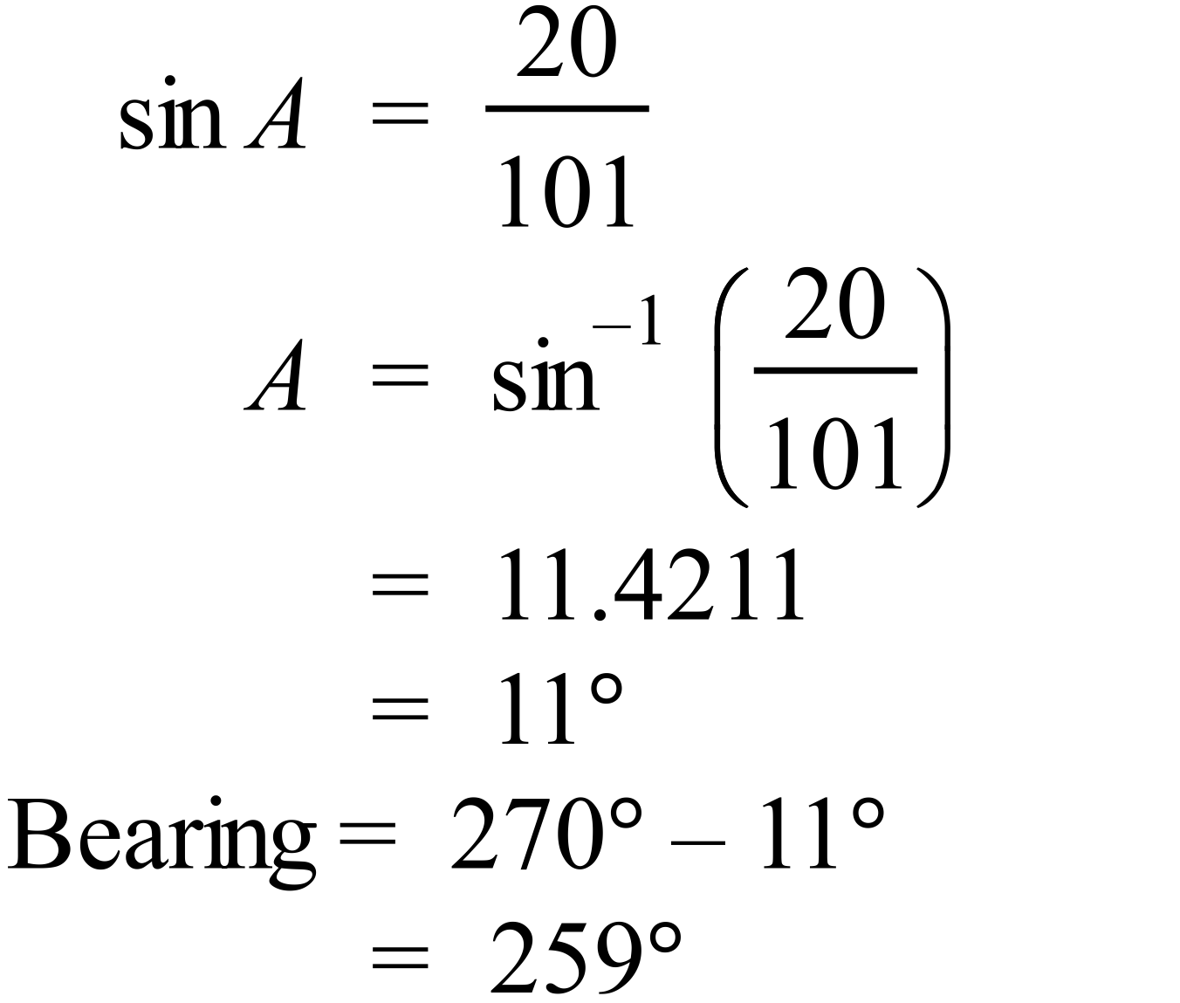 |  | 259º
 | 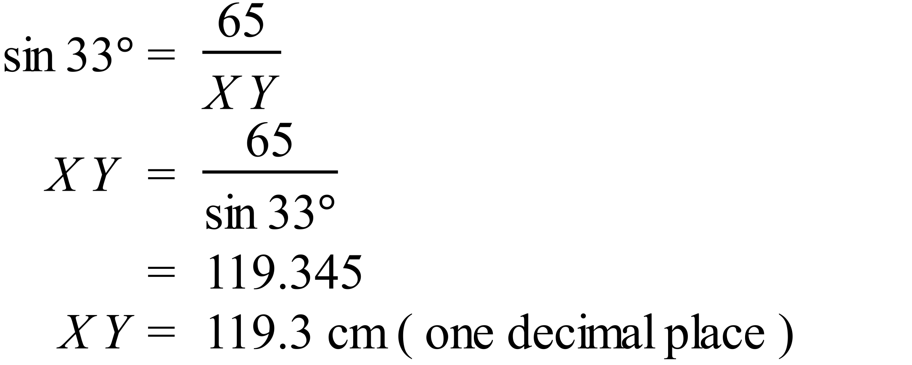 |  | 119.3 cm
 | 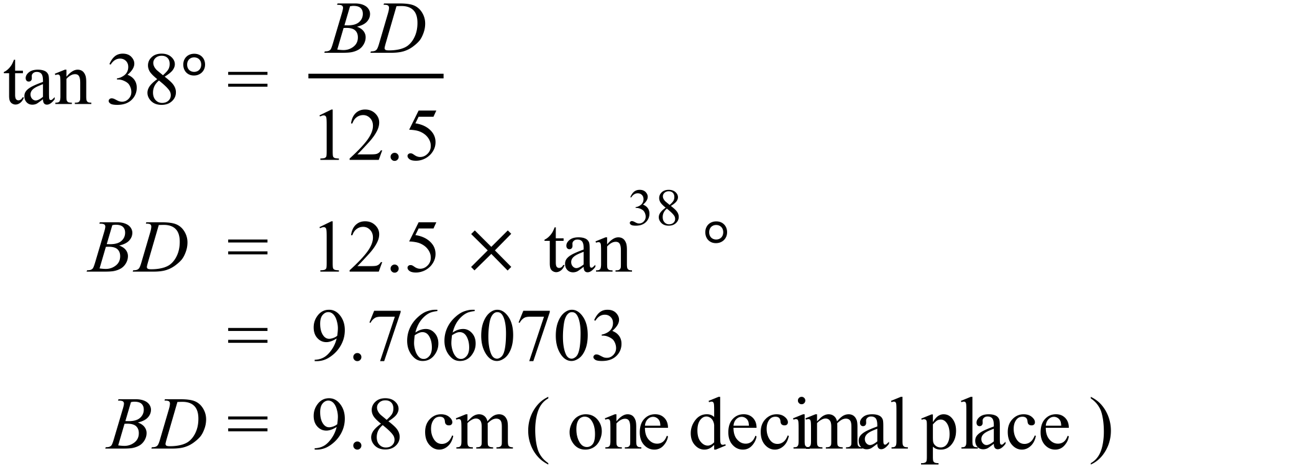  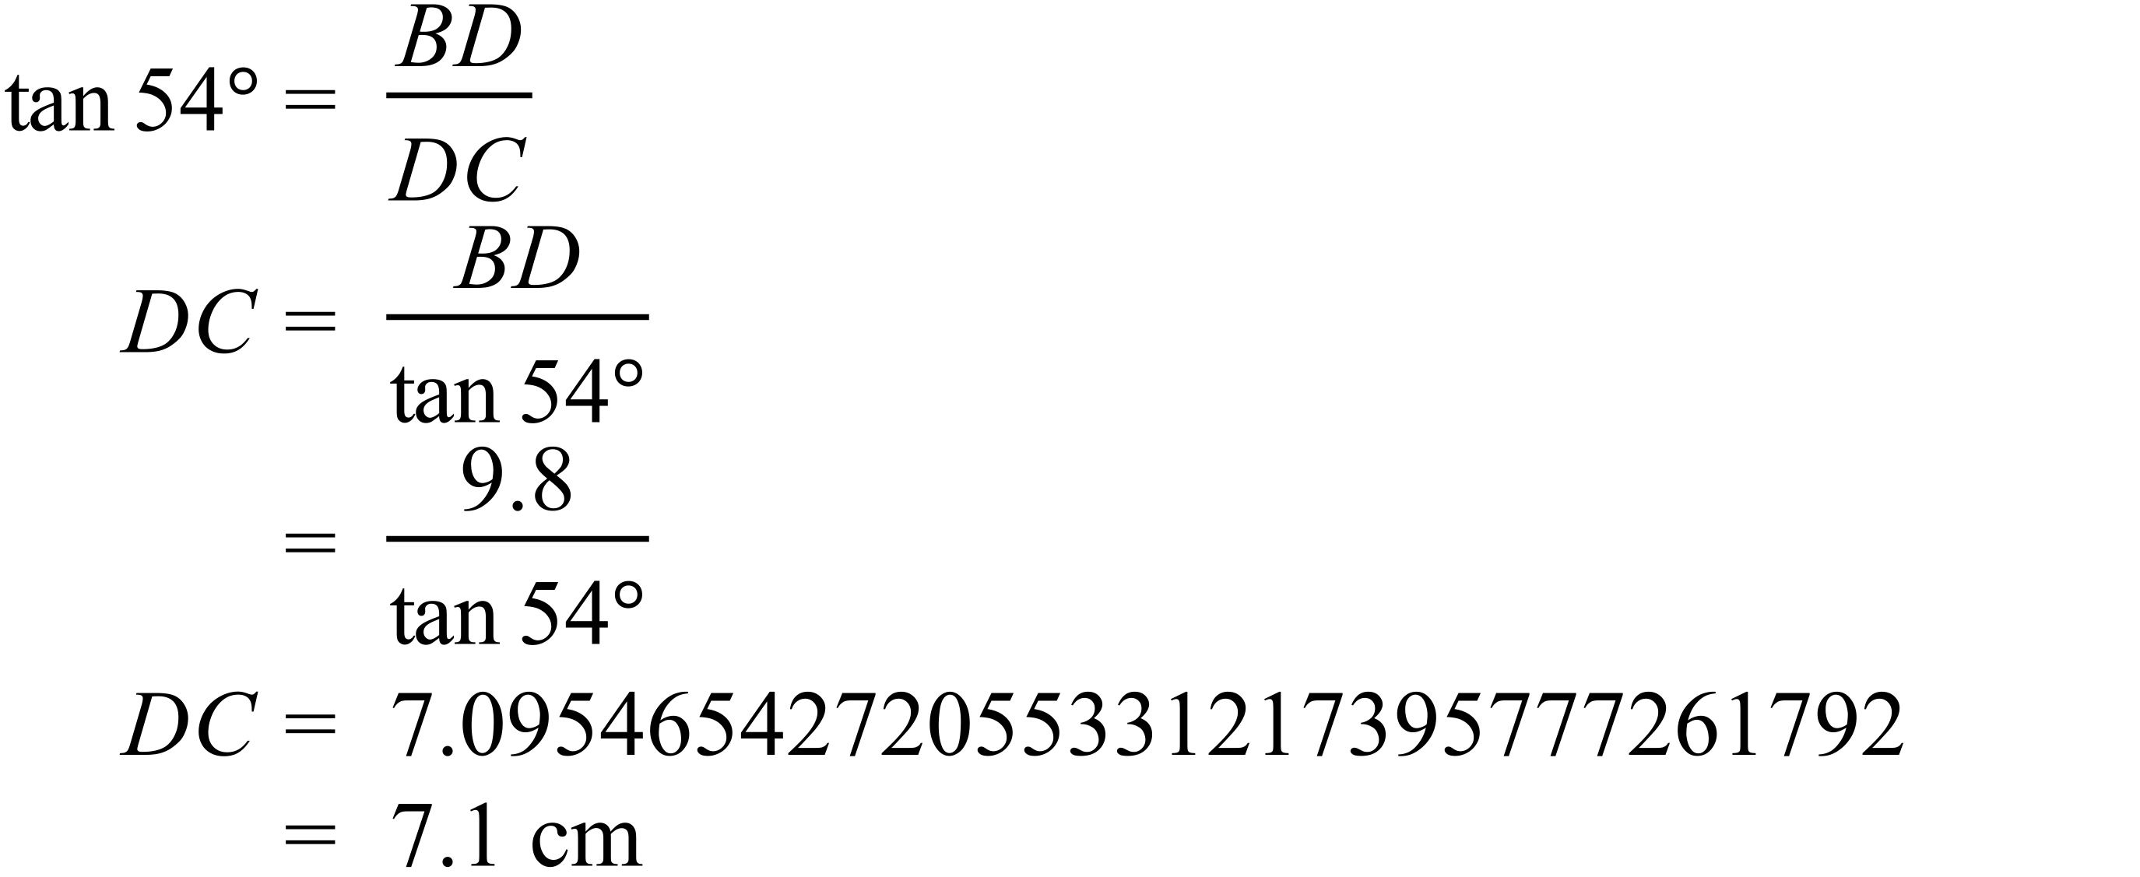 |  | 7.1 cm

Year 9 |  | Right Triangle Trigonometry | Calculator Allowed
Section 2 Multiple Choice Section
ANSWERS
No. | WORKING |  |  | ANSWER
 | 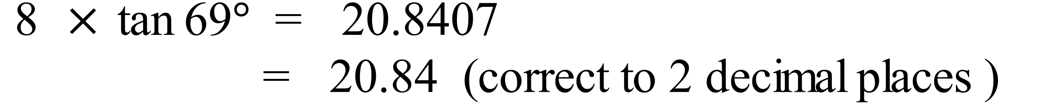 |  |  | D
 |  |  |  | C
 | 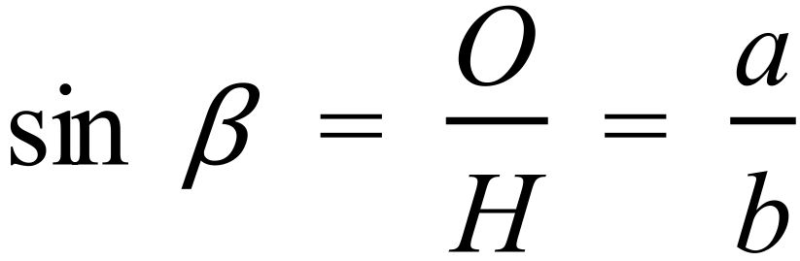 |  |  | A
 | 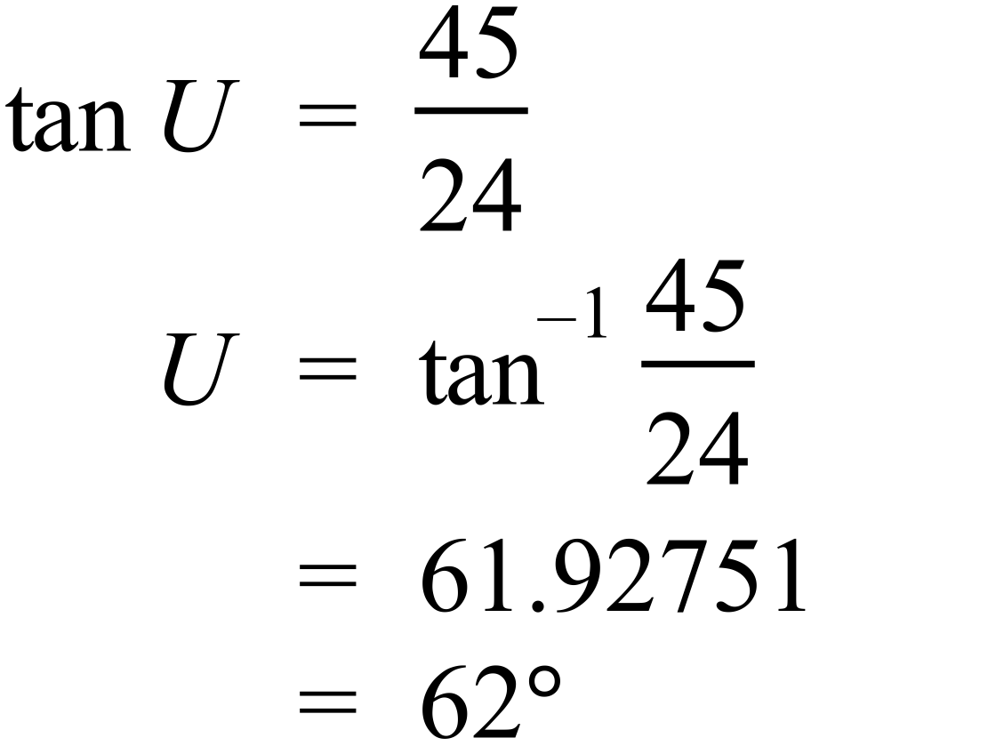 Can be done using cos or sin as well. |  |  | D
 | 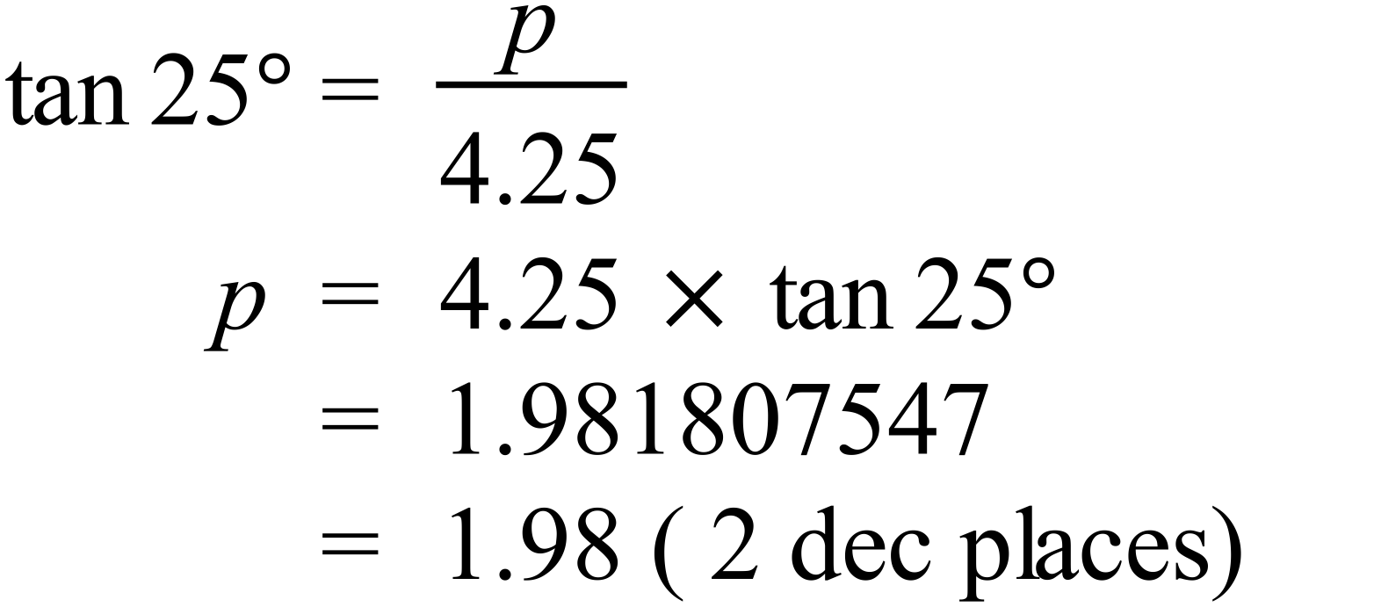 |  |  | B
 | 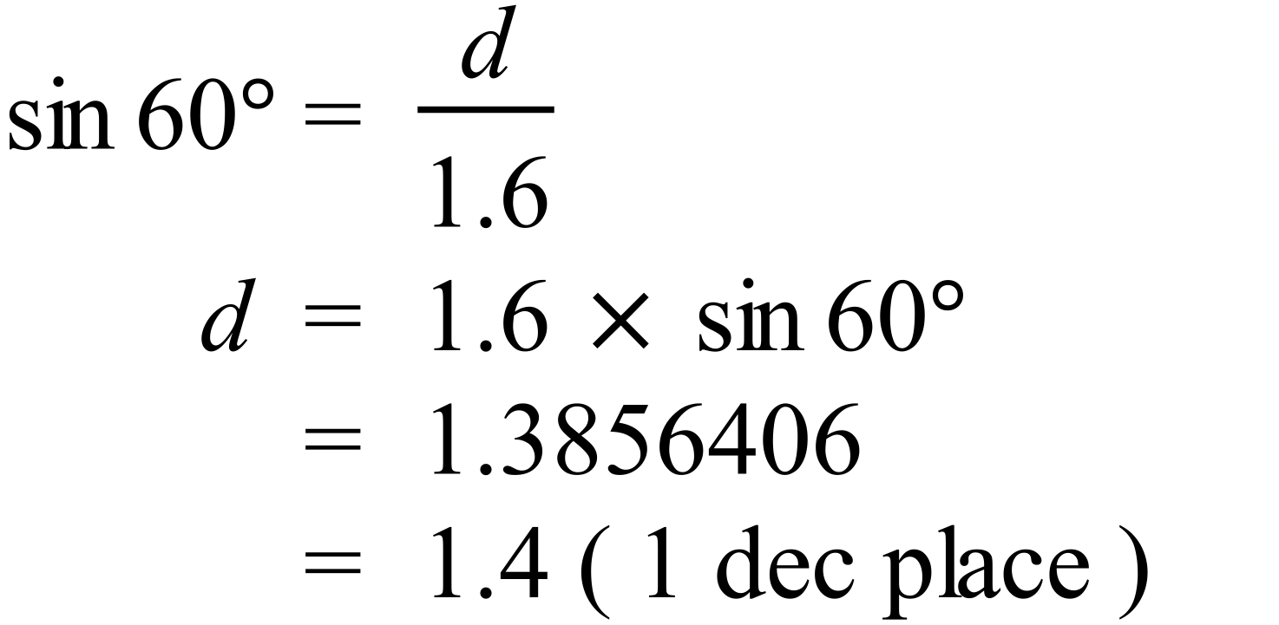 |  |  | B
 | 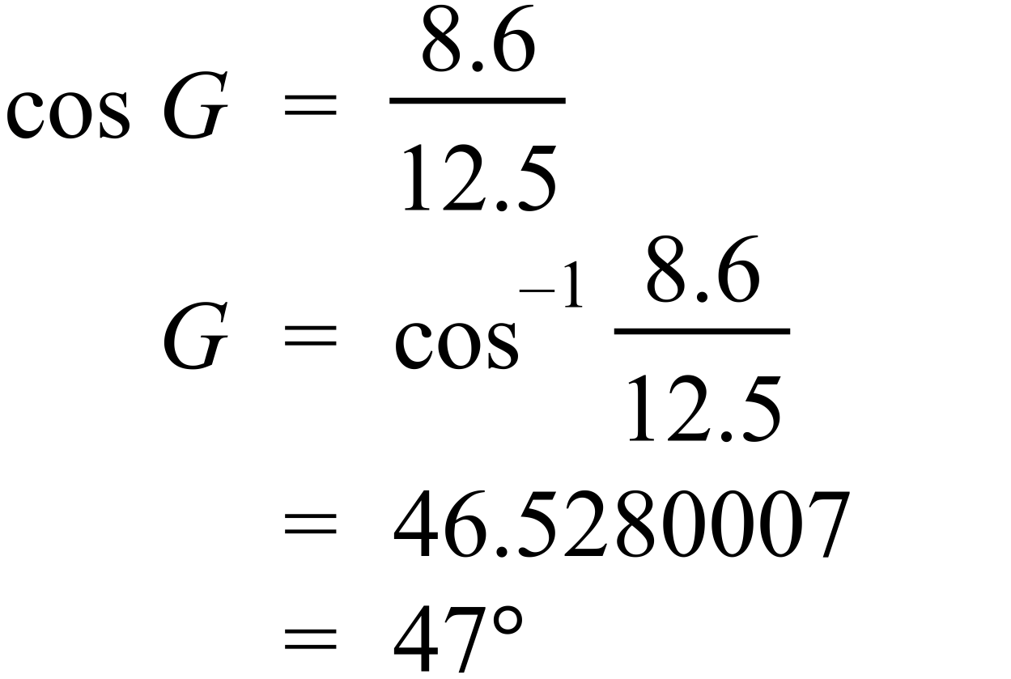 |  |  | C
 | 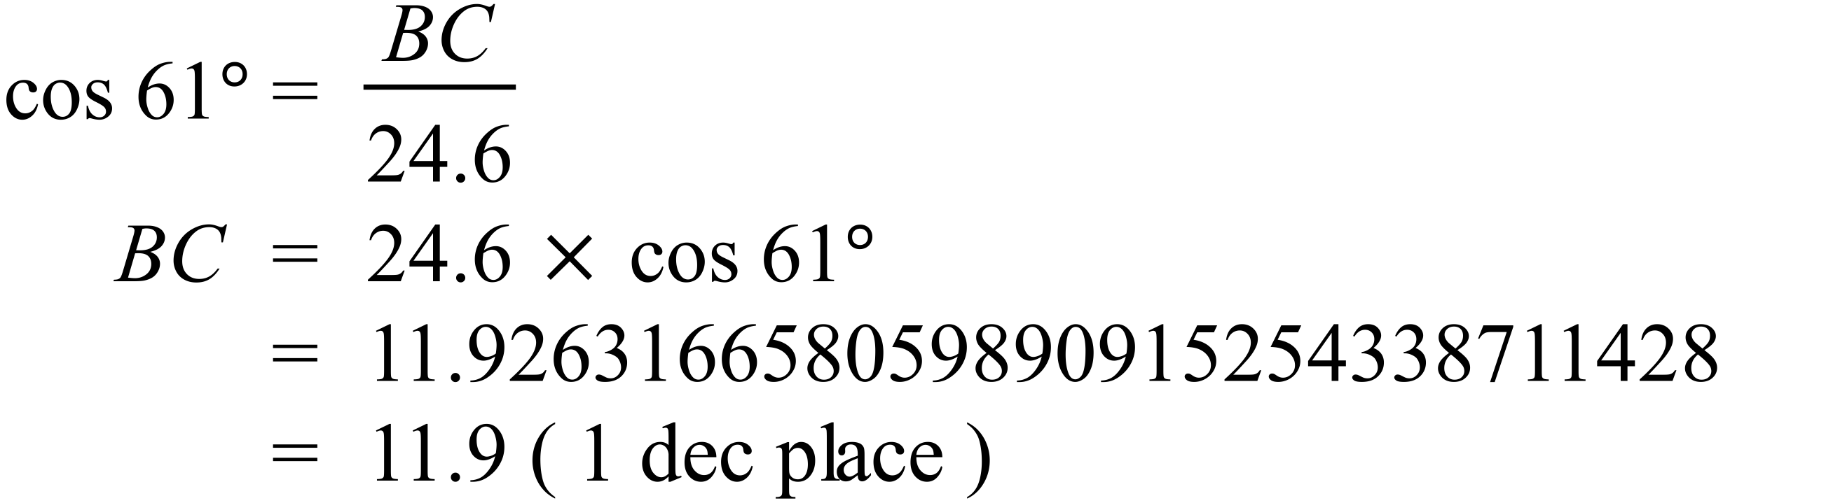 |  |  | A
 | 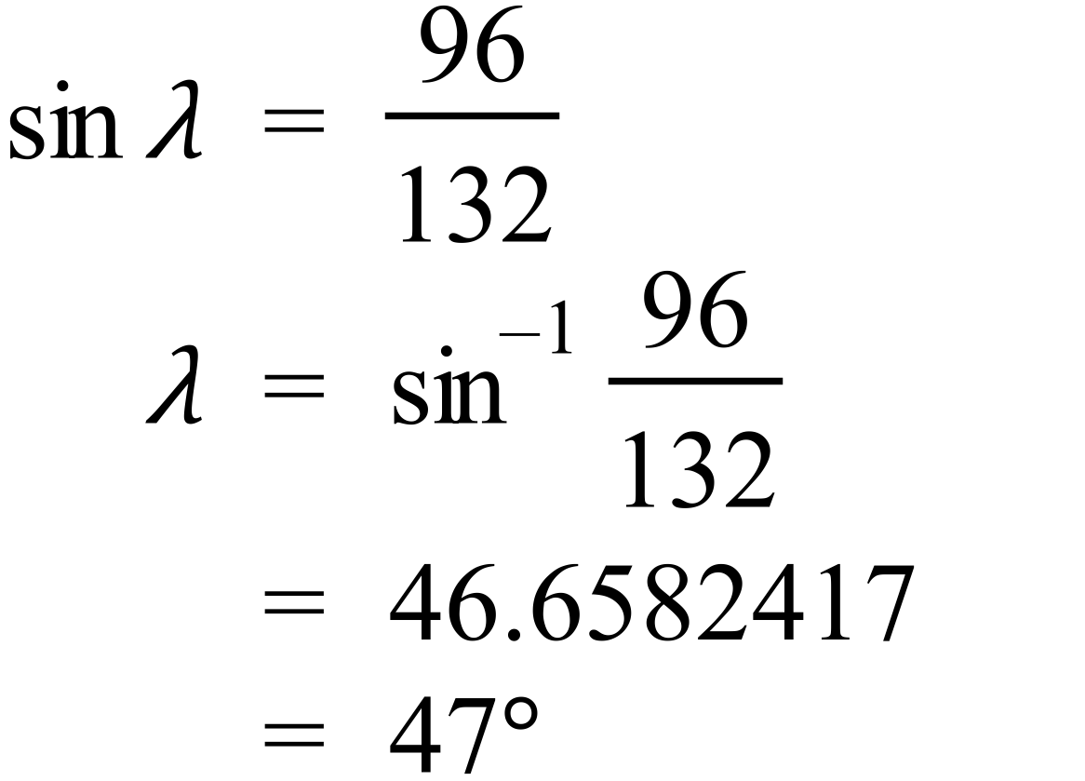 |  |  | D
 | 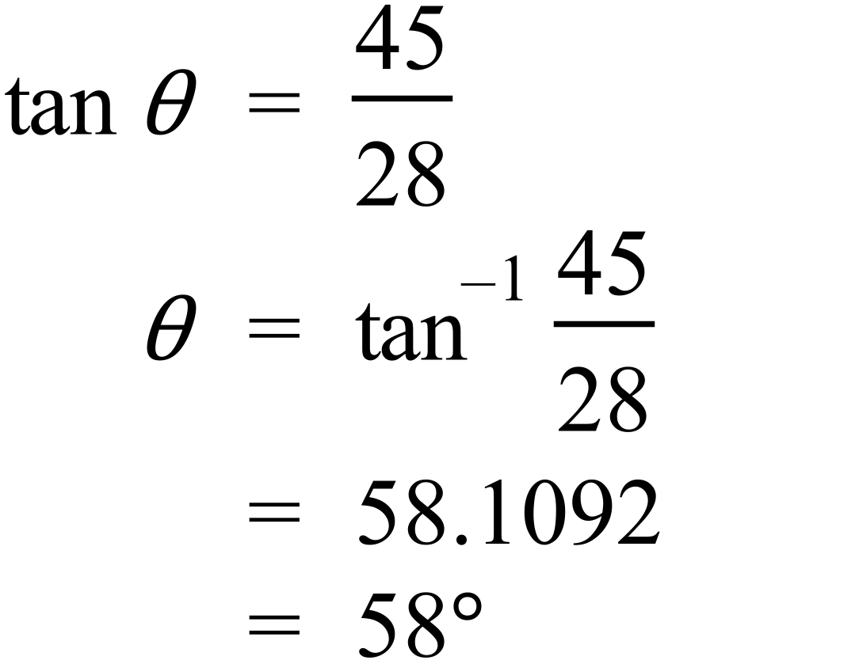 |  |  | D
 | 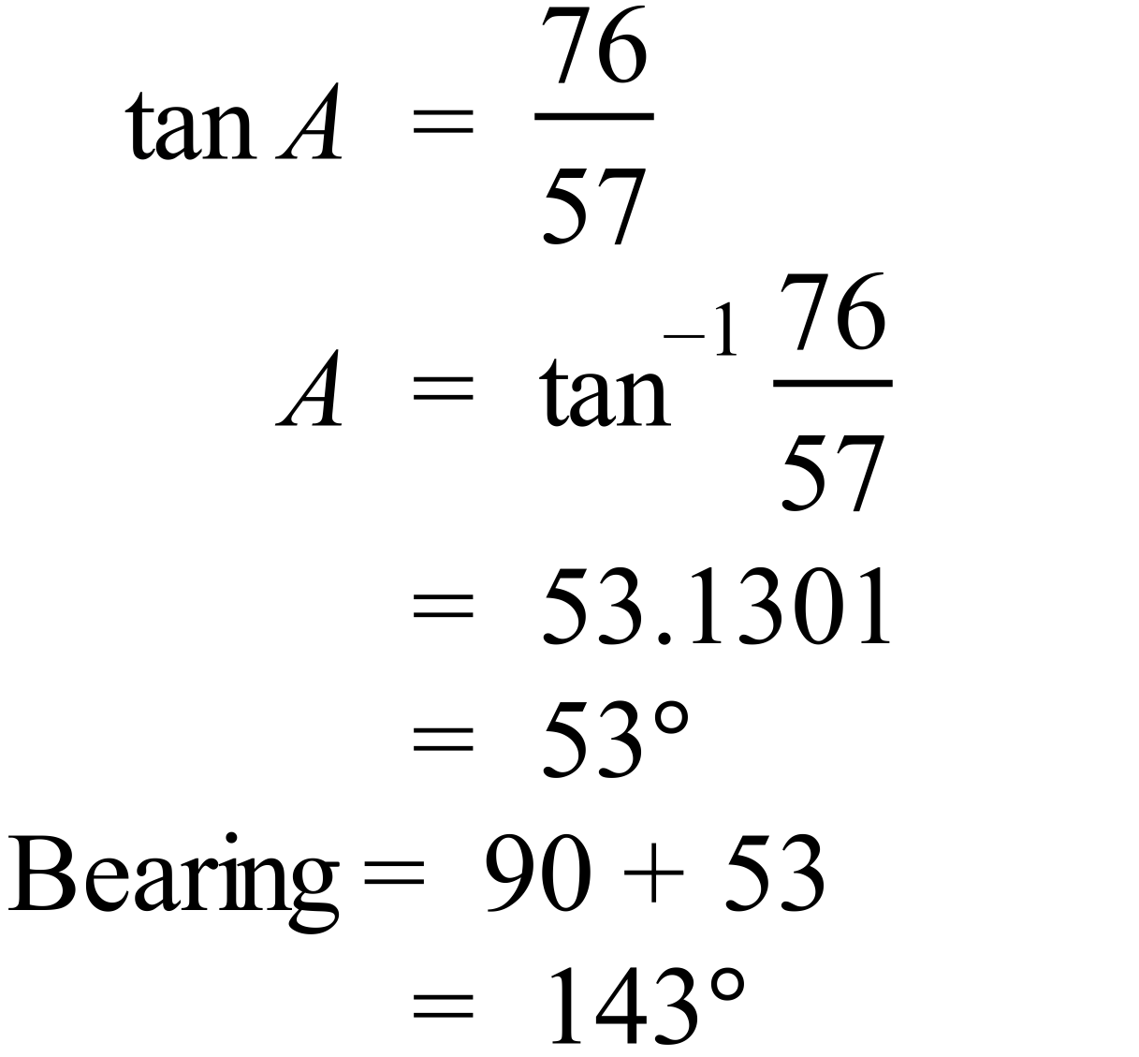 |  |  | C
 | 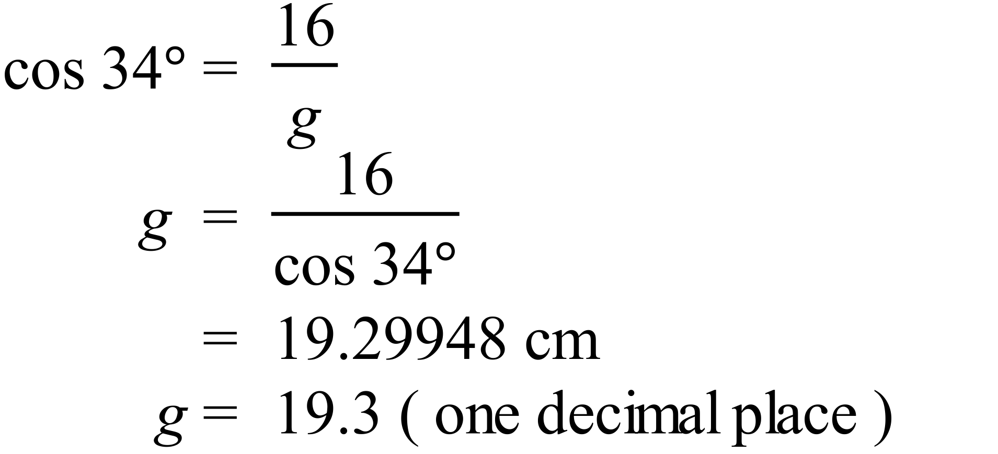 |  |  | B
 | 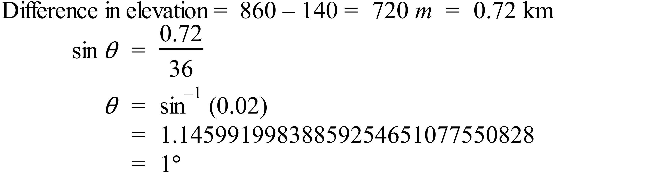 |  |  | A
 | 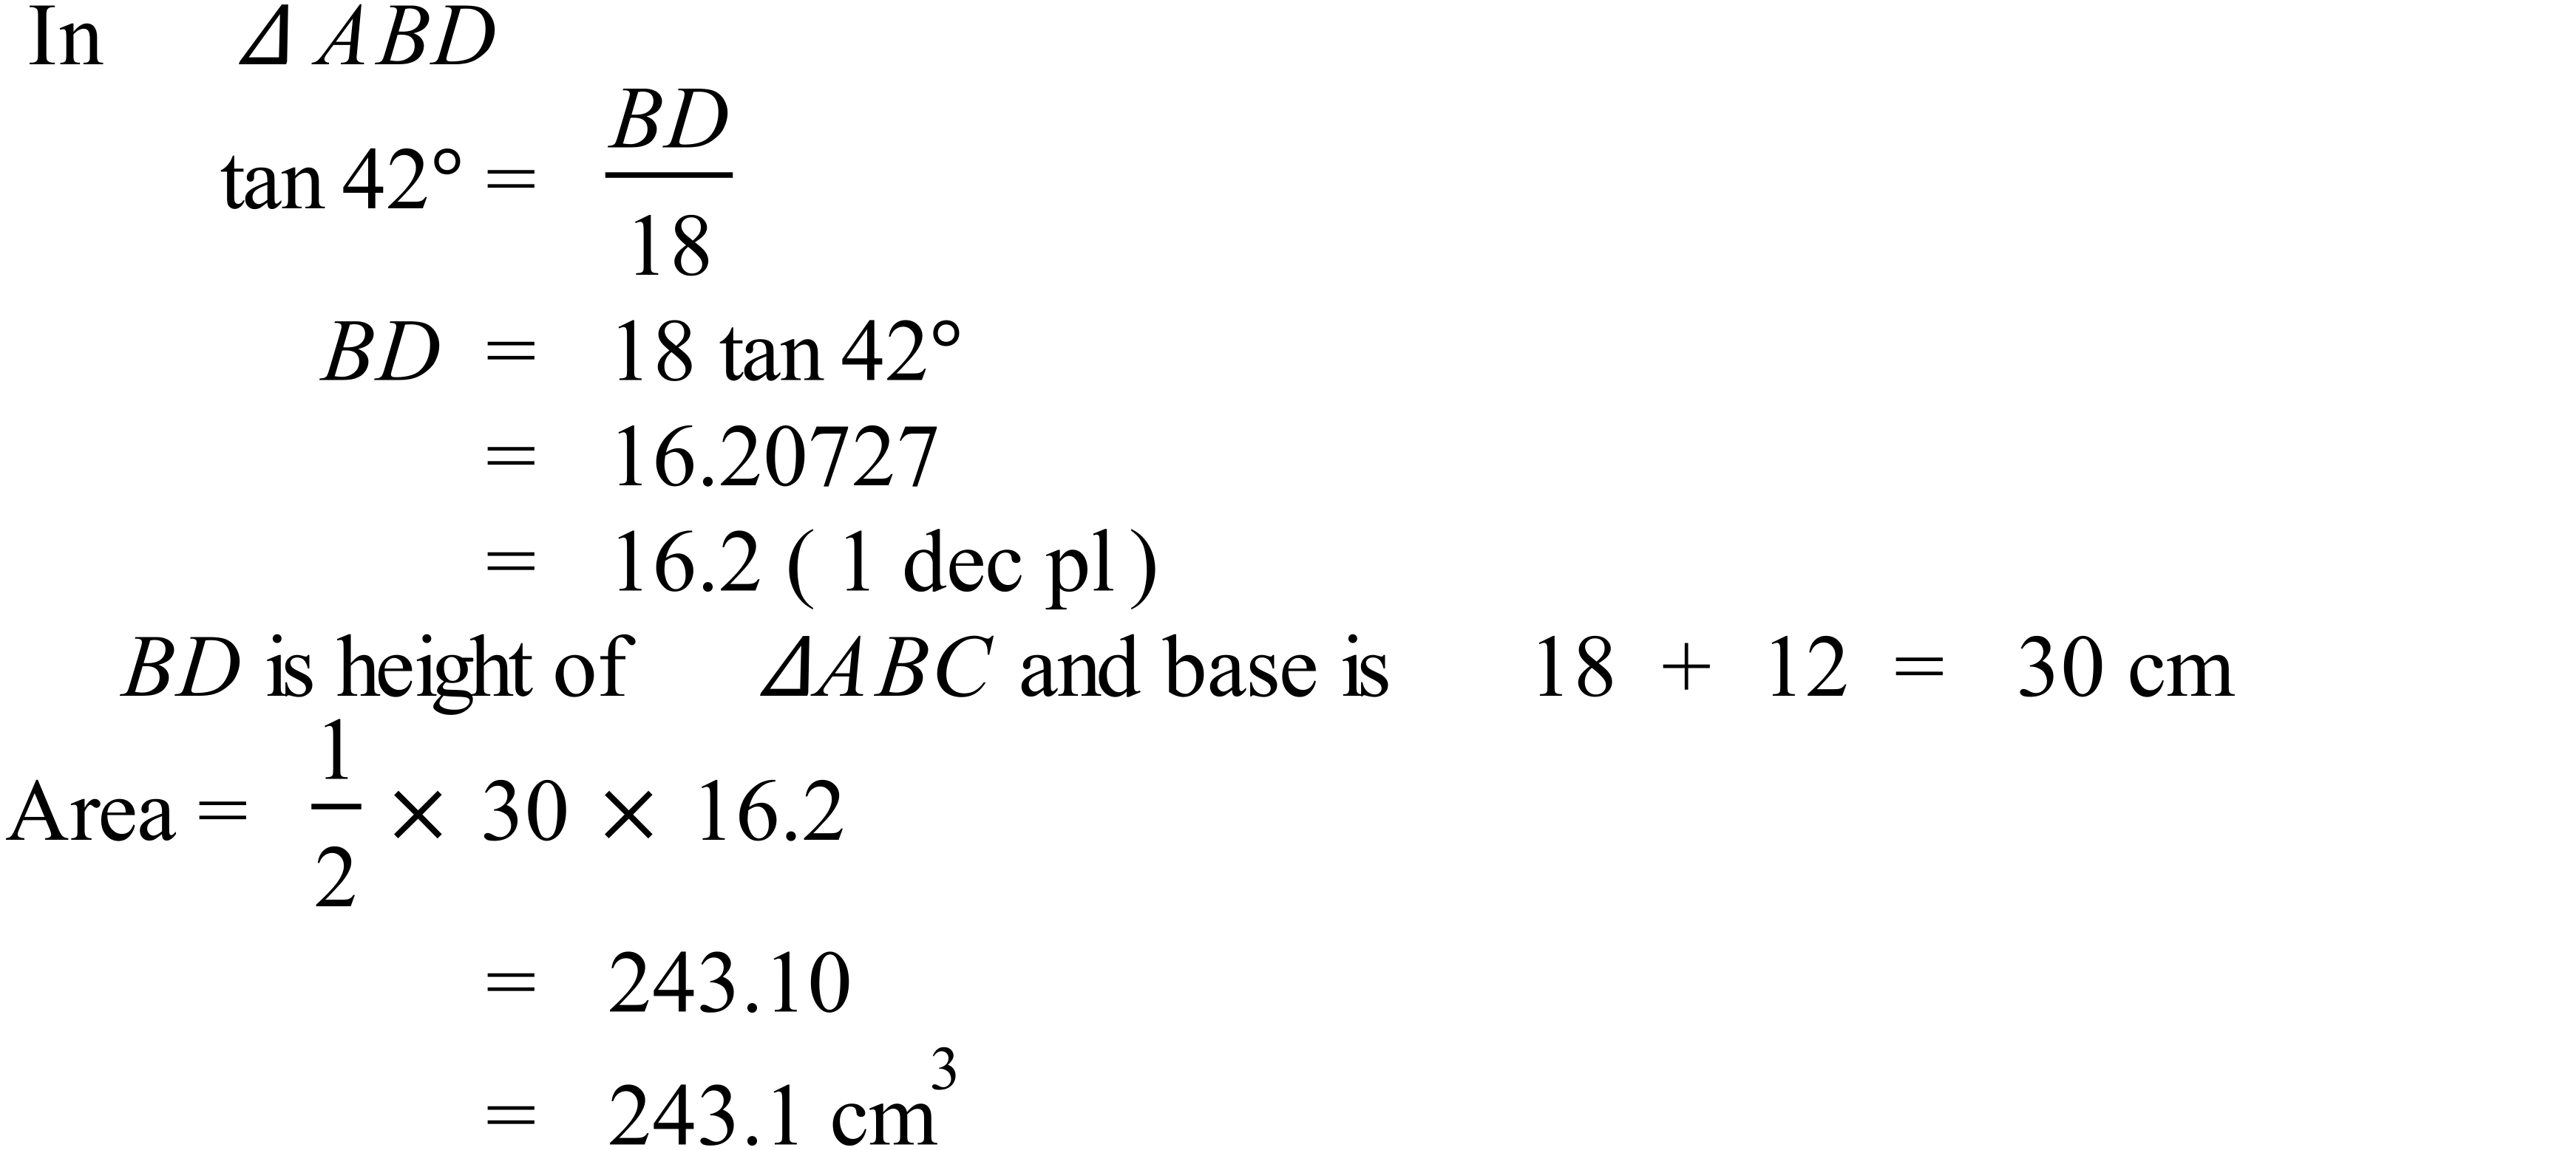 |  |  | A
 | 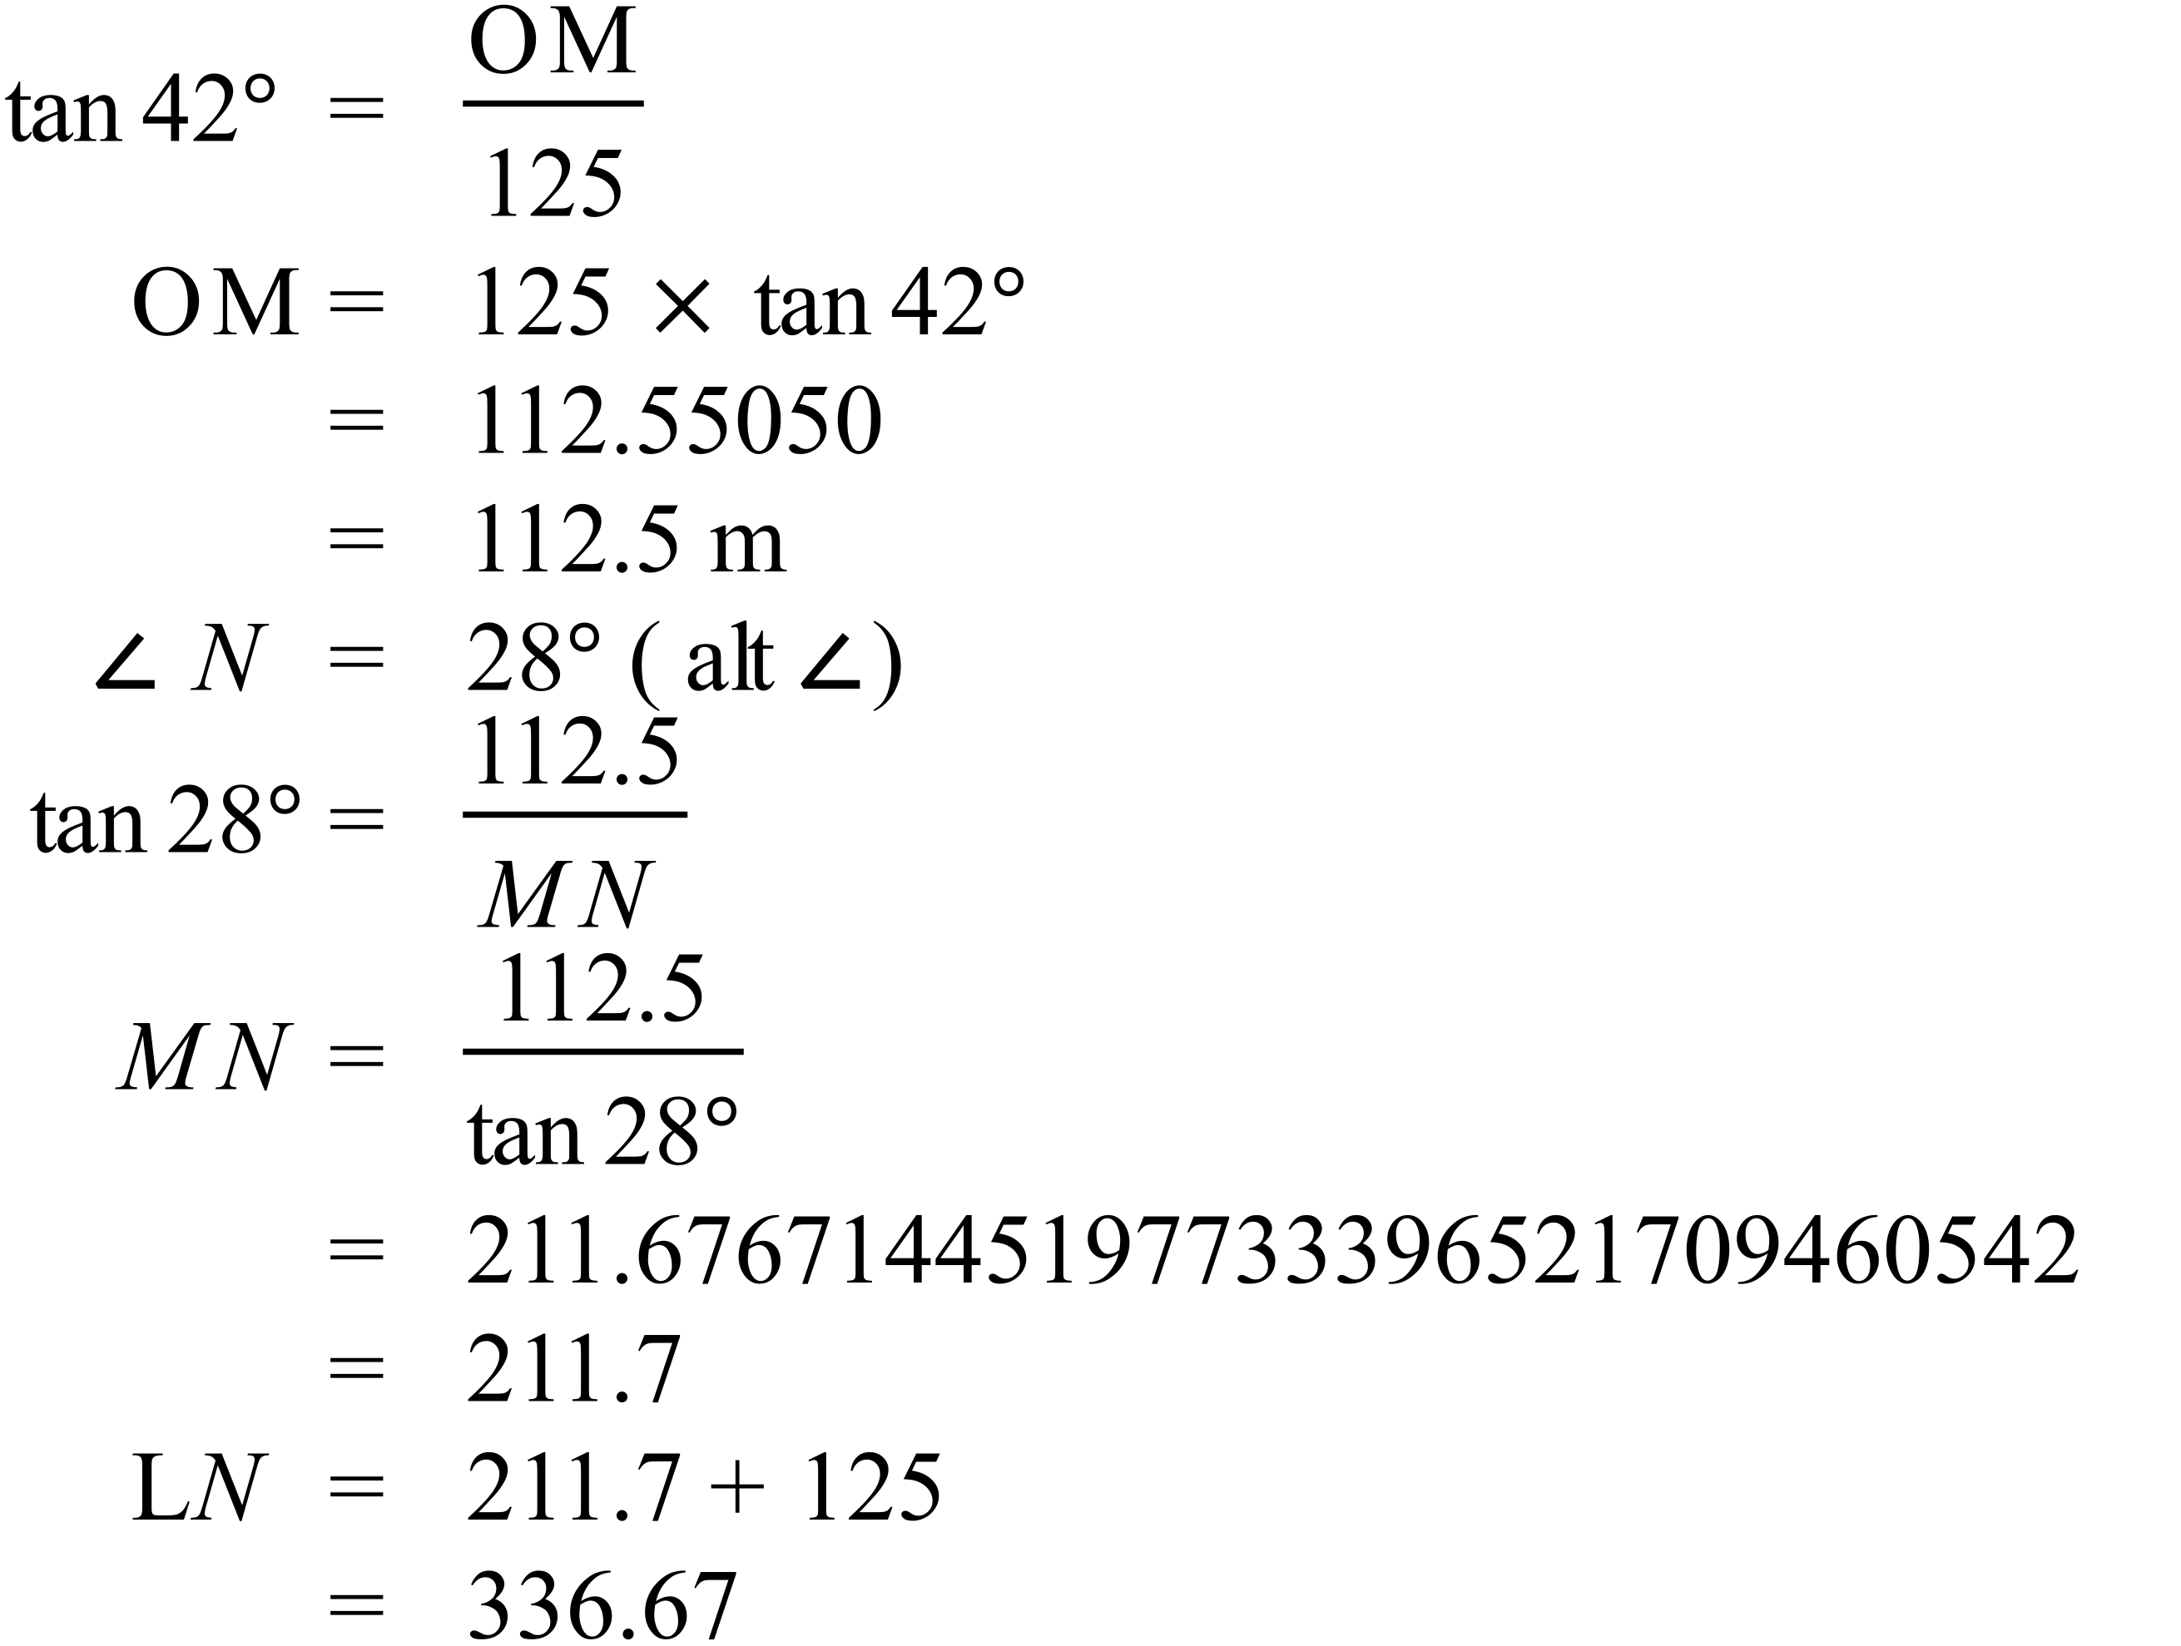 |  |  | C

Multiple Choice Answer Sheet
Right Triangle Trigonometry
Name _______ANSWERS_______________________________
Completely fill the response oval representing the most correct answer.

1. A B C D
2. A B C D
3. A B C D
4. A B C D
5. A B C D
6. A B C D
7. A B C D
8. A B C D
9. A B C D
10. A B C D
11. A B C D
12. A B C D
13. A B C D
14. A B C D
15. A B C D

